Sessions:

☐ Quantum, non-linear and laser optics | ☐ Optical design, manufacturing & imaging systems
☐ Biosensing & Biophotonics: from micro- to nanoscale | ☒ Nanophotonics, plasmonics & metamaterials

Electric dipole tailoring for highly directional excitation in parity-time symmetric waveguides

A. De Corte¹, and B. Maes¹
¹Micro- and Nanophotonic Materials Group, Research Institute for Materials Science and Engineering, University of Mons, 20 Place du Parc, B-7000 Mons, Belgium

Abstract: Photonic structures offer a flexible platform for studying and demonstrating parity-time (PT) symmetry phenomena [1]. In these platforms, electric dipoles are often used as accurate models for electromagnetic sources, and elliptical dipoles were shown to provide for directional mode excitation [2]. Here, we tailor the polarization of an electric dipole to cancel one of the modes of two coupled PT-symmetric waveguides (Fig. 1(a)). This creates a contrast between wave propagation on both sides of the dipole, which manifests differently depending on the unique features of the modes in the various PT regimes. Interestingly, before the exceptional point (EP), a linear dipole suffices to have mode beatings on only one side (Fig. 1(b)). Furthermore, beyond the EP, gain can be created on one side only (Fig. 1(d)). Finally, at the EP, a near-complete directionality can be achieved due to the mode merging (Fig. 1(c)). These effects are explained via a detailed analysis of the modes and an analytical description of the dipole-mode coupling. An eigenmode expansion Maxwell equations’ solver is used to model the structure and simulate these behaviors. [3] In the end, these various types of contrasting phenomena offer new possibilities for integrated photonics applications, routing setups, and lasing behavior.

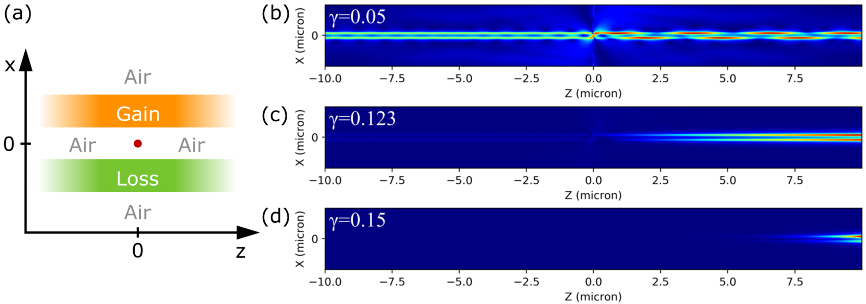
Figure1. (a) Schema of the photonic structure used in the simulations. Gain and loss materials are represented in orange and green, respectively, and air in white. The dipole is marked by a red dot. The waveguides are infinite in the z direction. (b-d) Magnetic field absolute value of the waves excited by the tailored dipoles for some specific gain/loss parameters $γ$ (b) before the EP (c) at the EP (d) beyond the EP.

We acknowledge the support of the French Community of Belgium within the framework of the financing of a FNRS-FRIA grant.

References
- L. Feng, R. El-Ganainy, and L. Ge, “Non-hermitian photonics based on parity–time symmetry”, Nature Photonics 11, 752 (2017).
- M. Picardi, A. Zayats, and F. Rodríguez-Fortuño, “Janus and huygens dipoles: Near-field directionality beyond spin-momentum locking”, Physical Review Letters 120, 117402 (2018).
- P. Bienstman, “Rigorous and efficient modelling of wavelength scale photonic components”, Ph.D. thesis, Universiteit Gent (2001).
- Alice De Corte and Bjorn Maes, “Tailoring of electric dipoles for highly directional propagation in parity-time-symmetric waveguides”, Phys. Rev. A, 106, 023509 (2022).

