Supplementary Material

Supplementary table 1. Description of each field with crop identity, year and geographic information: region, locality, latitude, longitude and altitude using World Geodetic System 1984 (WGS 84). “C” indicates control field (i.e. the main crop only) and “FAP” indicates Farming with Alternative Pollinators field (main crop in 75 % of the field surrounded by MHEP in the 25 % area)
Crops | Field | Year | Region | Locality | Latitude | Longitude | Altitude
Cucurbita maxima | C1 | 2018 | Sefrou | Laanoussar | 33.6234169 | -4.90019703 | 1474
Cucurbita maxima | C2 | 2018 | Sefrou | Laanoussar | 33.6234169 | -4.90019703 | 1474
Cucurbita maxima | C3 | 2018 | Sefrou | Laanoussar | 33.6234169 | -4.90019703 | 1474
Cucurbita maxima | FAP1 | 2018 | Sefrou | Laanoussar | 33.6234169 | -4.90019703 | 1474
Cucurbita maxima | FAP2 | 2018 | Sefrou | Laanoussar | 33.6234169 | -4.90019703 | 1474
Cucurbita maxima | FAP3 | 2018 | Sefrou | Laanoussar | 33.6234169 | -4.90019703 | 1474
Cucurbita maxima | FAP4 | 2018 | Sefrou | Laanoussar | 33.6234169 | -4.90019703 | 1474
Cucurbita maxima | FAP5 | 2018 | Sefrou | Laanoussar | 33.6234169 | -4.90019703 | 1474
Cucurbita maxima | C1 | 2018 | Settat | Mzamza Janoubia | 32.93170166 | -7.49230003 | 546
Cucurbita maxima | C2 | 2018 | Settat | Mzamza Janoubia | 32.97470093 | -7.5158 | 450
Cucurbita maxima | FAP1 | 2018 | Settat | Mzamza Janoubia | 32.94879913 | -7.49510002 | 525
Cucurbita maxima | FAP2 | 2018 | Settat | Mzamza Janoubia | 32.95240021 | -7.51420021 | 509
Cucurbita maxima | FAP3 | 2018 | Settat | Mzamza Janoubia | 32.97198868 | -7.49296856 | 475
Cucurbita maxima | FAP4 | 2018 | Settat | Mzamza Janoubia | 32.95640182 | -7.53060007 | 534
Cucurbita maxima | FAP5 | 2018 | Settat | Mzamza Janoubia | 32.96962357 | -7.51781845 | 457
Vicia faba | C1 | 2018 | Kenitra | Haddada | 34.12107849 | -6.56302357 | 97
Vicia faba | C2 | 2018 | Kenitra | Haddada | 34.14984894 | -6.54176664 | 132
Vicia faba | C3 | 2018 | Kenitra | Haddada | 34.11984634 | -6.57578945 | 110
Vicia faba | FAP1 | 2018 | Kenitra | Haddada | 34.12513351 | -6.57340288 | 112
Vicia faba | FAP2 | 2018 | Kenitra | Haddada | 34.12843704 | -6.55921745 | 125
Vicia faba | FAP3 | 2018 | Kenitra | Haddada | 34.11808395 | -6.55127525 | 105
Vicia faba | FAP4 | 2018 | Kenitra | Haddada | 34.14526749 | -6.54862785 | 122
Vicia faba | FAP5 | 2018 | Kenitra | Haddada | 34.13537598 | -6.54006386 | 67
Vicia faba | C1 | 2018 | Sefrou | Laanoussar | 33.6256218 | -4.89916658 | 1515
Vicia faba | C2 | 2018 | Sefrou | Laanoussar | 33.6203804 | -4.88003969 | 1502
Vicia faba | C3 | 2018 | Sefrou | Laanoussar | 33.62033463 | -4.87956333 | 1418
Vicia faba | FAP1 | 2018 | Sefrou | Laanoussar | 33.6256218 | -4.89916658 | 1461
Vicia faba | FAP2 | 2018 | Sefrou | Laanoussar | 33.7098732 | -4.84313679 | 1285
Vicia faba | FAP4 | 2018 | Sefrou | Sidi Youssef Ben Ahmed | 33.82535172 | -4.78015709 | 753
Vicia faba | FAP5 | 2018 | Sefrou | Sidi Youssef Ben Ahmed | 33.81951904 | -4.76402617 | 821
Vicia faba | C1 | 2018 | Settat | Oueled Sghir | 32.82870102 | -7.63980007 | 490
Vicia faba | C2 | 2018 | Settat | Oueled Sghir | 32.82301712 | -7.64213324 | 463
Vicia faba | C3 | 2018 | Settat | Oueled Sghir | 32.82592392 | -7.63709307 | 472
Vicia faba | FAP1 | 2018 | Settat | Oueled Sghir | 32.83789825 | -7.62160015 | 507
Vicia faba | FAP2 | 2018 | Settat | Oueled Sghir | 32.82302856 | -7.62245321 | 493
Vicia faba | FAP3 | 2018 | Settat | Oueled Sghir | 32.84564209 | -7.63749266 | 484
Vicia faba | FAP4 | 2018 | Settat | Oueled Sghir | 32.80488968 | -7.62752628 | 476
Cucurbita maxima | C1 | 2019 | Errachidia | Sidi Boukil | 32.24020004 | -4.72840023 | 1443
Cucurbita maxima | C2 | 2019 | Errachidia | Sidi Boukil | 32.22359848 | -4.68529987 | 1419
Cucurbita maxima | C3 | 2019 | Errachidia | Ait Said | 32.23830032 | -4.6624999 | 1406
Cucurbita maxima | FAP1 | 2019 | Errachidia | Mzizl | 32.22340012 | -4.69210005 | 1419
Cucurbita maxima | FAP2 | 2019 | Errachidia | Sidi Boukil | 32.2276001 | -4.69649982 | 1421
Cucurbita maxima | FAP3 | 2019 | Errachidia | Ait Said | 32.22520065 | -4.69770002 | 1423
Cucurbita maxima | FAP4 | 2019 | Errachidia | Sidi Boukil | 32.23649979 | -4.7112999 | 1432
Cucurbita maxima | FAP5 | 2019 | Errachidia | Sidi Boukil | 32.22769928 | -4.71430016 | 1439
Cucurbita maxima | C1 | 2019 | Kenitra | Haddada | 34.13970184 | -6.53520012 | 65
Cucurbita maxima | C2 | 2019 | Kenitra | Bouknadel | 34.09140015 | -6.59030008 | 107
Cucurbita maxima | C3 | 2019 | Kenitra | Haddada | 34.10829926 | -6.55950022 | 119
Cucurbita maxima | FAP1 | 2019 | Kenitra | Haddada | 34.1208992 | -6.56279993 | 100
Cucurbita maxima | FAP2 | 2019 | Kenitra | Haddada | 34.12829971 | -6.55919981 | 125
Cucurbita maxima | FAP3 | 2019 | Kenitra | Haddada | 34.11980057 | -6.57579994 | 110
Cucurbita maxima | FAP4 | 2019 | Kenitra | Haddada | 34.06169891 | -6.62470007 | 121
Cucurbita maxima | FAP5 | 2019 | Kenitra | Bouknadel | 34.06520081 | -6.61299992 | 115
Cucurbita maxima | C1 | 2019 | Sefrou | Sidi Ahmed Ben youssef | 33.83380127 | -4.75110006 | 772
Cucurbita maxima | C2 | 2019 | Sefrou | Sidi Ahmed Ben youssef | 33.81669998 | -4.76280022 | 824
Cucurbita maxima | C3 | 2019 | Sefrou | Sidi Ahmed Ben youssef | 33.83580017 | -4.74690008 | 770
Cucurbita maxima | FAP1 | 2019 | Sefrou | Aghbalou Aqorar | 33.85979843 | -4.65929985 | 561
Cucurbita maxima | FAP2 | 2019 | Sefrou | Aghbalou Aqorar | 33.8885994 | -4.63940001 | 592
Cucurbita maxima | FAP3 | 2019 | Sefrou | Aghbalou Aqorar | 33.8995018 | -4.64120007 | 587
Cucurbita maxima | FAP4 | 2019 | Sefrou | Sidi Ahmed Ben youssef | 33.81570053 | -4.77250004 | 831
Cucurbita maxima | FAP5 | 2019 | Sefrou | Sidi Ahmed Ben youssef | 33.80780029 | -4.76230001 | 826
Cucurbita maxima | C1 | 2019 | Settat | Oueled Sghir | 32.82870102 | -7.63980007 | 490
Cucurbita maxima | C2 | 2019 | Settat | Oueled Sghir | 32.82239914 | -7.66919994 | 458
Cucurbita maxima | C3 | 2019 | Settat | Oueled Sghir | 32.8291861 | -7.6512451 | 469
Cucurbita maxima | FAP1 | 2019 | Settat | Oueled Sghir | 32.83789825 | -7.62160015 | 507
Cucurbita maxima | FAP2 | 2019 | Settat | Oueled Sghir | 32.82889938 | -7.65129995 | 481
Cucurbita maxima | FAP3 | 2019 | Settat | Oueled Sghir | 32.83160019 | -7.62939978 | 440
Cucurbita maxima | FAP4 | 2019 | Settat | Oueled Sghir | 32.82279968 | -7.6420002 | 459
Cucurbita maxima | FAP5 | 2019 | Settat | Oueled Sghir | 32.82590103 | -7.63679981 | 473
Vicia faba | C1 | 2019 | Errachidia | Sidi Boukil | 32.23490143 | -4.67420006 | 1410
Vicia faba | C2 | 2019 | Errachidia | Sidi Boukil | 32.23649979 | -4.6711998 | 1409
Vicia faba | C3 | 2019 | Errachidia | Tabia | 32.22980118 | -4.67789984 | 1413
Vicia faba | FAP1 | 2019 | Errachidia | Mzizl | 32.22119904 | -4.75299978 | 1479
Vicia faba | FAP2 | 2019 | Errachidia | Sidi Boukil | 32.23109818 | -4.71010017 | 1433
Vicia faba | FAP3 | 2019 | Errachidia | Ait Said | 32.24280167 | -4.66160011 | 1408
Vicia faba | FAP4 | 2019 | Errachidia | Sidi Boukil | 32.22510147 | -4.69460011 | 1422
Vicia faba | FAP5 | 2019 | Errachidia | Sidi Boukil | 32.22539902 | -4.704 | 1429
Vicia faba | C1 | 2019 | Kenitra | Haddada | 34.1208992 | -6.56279993 | 100
Vicia faba | C2 | 2019 | Kenitra | Haddada | 34.09140015 | -6.59030008 | 107
Vicia faba | C3 | 2019 | Kenitra | Haddada | 34.10829926 | -6.55940008 | 119
Vicia faba | FAP1 | 2019 | Kenitra | Haddada | 34.13970184 | -6.53520012 | 65
Vicia faba | FAP2 | 2019 | Kenitra | Haddada | 34.12829971 | -6.55919981 | 125
Vicia faba | FAP3 | 2019 | Kenitra | Haddada | 34.11980057 | -6.57579994 | 110
Vicia faba | FAP4 | 2019 | Kenitra | Bouknadel | 34.06169891 | -6.62470007 | 121
Vicia faba | FAP5 | 2019 | Kenitra | Haddada | 34.06520081 | -6.61307001 | 115
Vicia faba | C1 | 2019 | Sefrou | Sidi Ahmed Ben youssef | 33.83420181 | -4.74700022 | 770
Vicia faba | C2 | 2019 | Sefrou | Sidi Ahmed Ben youssef | 33.83409882 | -4.75099993 | 772
Vicia faba | C3 | 2019 | Sefrou | Sidi Ahmed Ben youssef | 33.82030106 | -4.76399994 | 808
Vicia faba | FAP1 | 2019 | Sefrou | Sidi Ahmed Ben youssef | 33.80649948 | -4.76819992 | 864
Vicia faba | FAP2 | 2019 | Sefrou | Aghbalou Aqorar | 33.90209961 | -4.64750004 | 579
Vicia faba | FAP3 | 2019 | Sefrou | Aghbalou Aqorar | 33.86439896 | -4.67140007 | 626
Vicia faba | FAP4 | 2019 | Sefrou | Azzaba | 33.85580063 | -4.70669985 | 706
Vicia faba | FAP5 | 2019 | Sefrou | Sidi Ahmed Ben youssef | 33.82080078 | -4.76109982 | 805
Vicia faba | C1 | 2019 | Settat | Oueled Sghir | 32.82870102 | -7.63980007 | 490
Vicia faba | C2 | 2019 | Settat | Oueled Sghir | 32.82590103 | -7.63679981 | 473
Vicia faba | C3 | 2019 | Settat | Oueled Sghir | 32.82260132 | -7.62209988 | 495
Vicia faba | FAP1 | 2019 | Settat | Oueled Sghir | 32.83789825 | -7.62160015 | 507
Vicia faba | FAP2 | 2019 | Settat | Oueled Sghir | 32.82239914 | -7.66919994 | 458
Vicia faba | FAP3 | 2019 | Settat | Oueled Sghir | 32.83160019 | -7.62939978 | 440
Vicia faba | FAP4 | 2019 | Settat | Oueled Sghir | 32.82279968 | -7.6420002 | 459
Vicia faba | FAP5 | 2019 | Settat | Oueled Sghir | 32.82889938 | -7.65129995 | 481

Supplementary Figure 1. Experimental designs of FAP fields (main crop in 75% of the field surrounded by marketable habitat enhancement plants) for each crop in Settat in 2018 and 2019
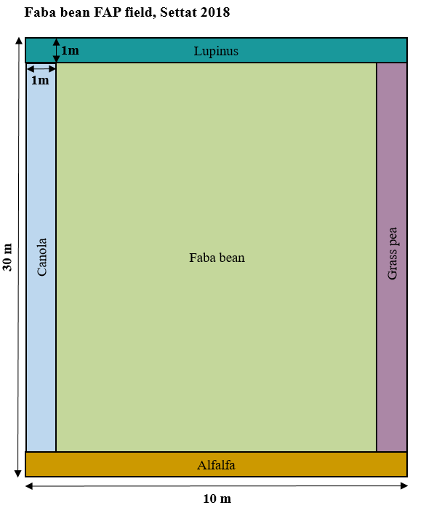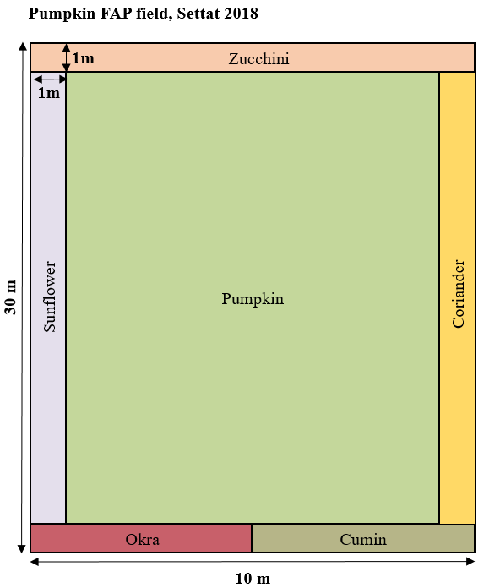
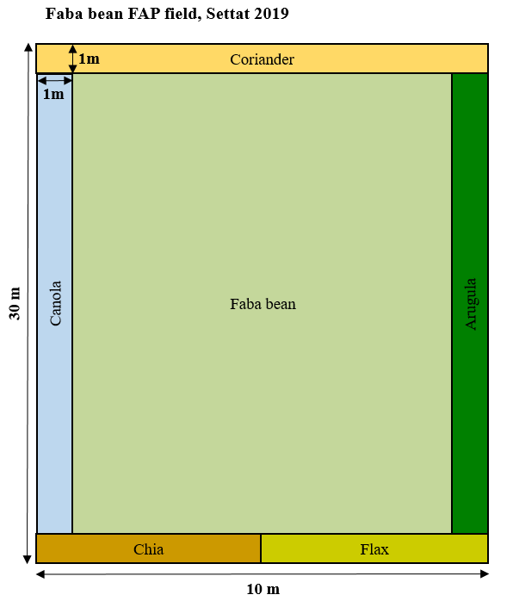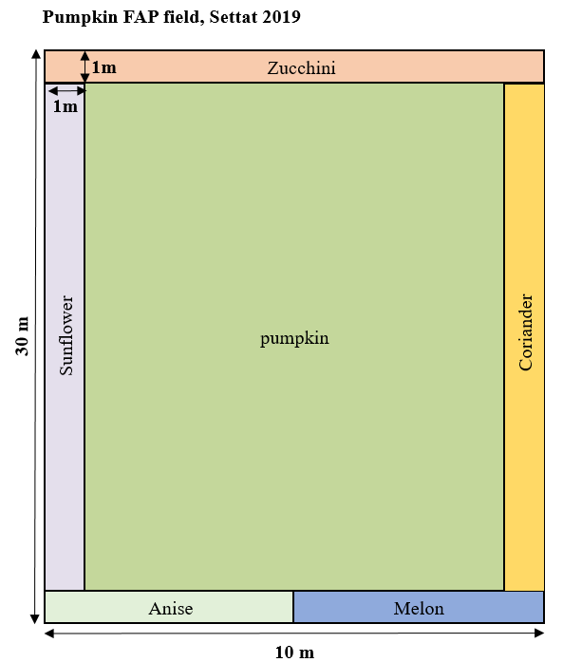
Supplementary Figure 2. Experimental designs of FAP fields (main crop in 75% of the field surrounded by marketable habitat enhancement plants) for each crop in Kenitra in 2018 and 2019
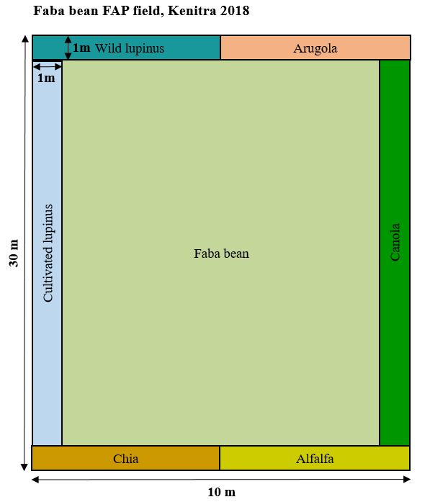
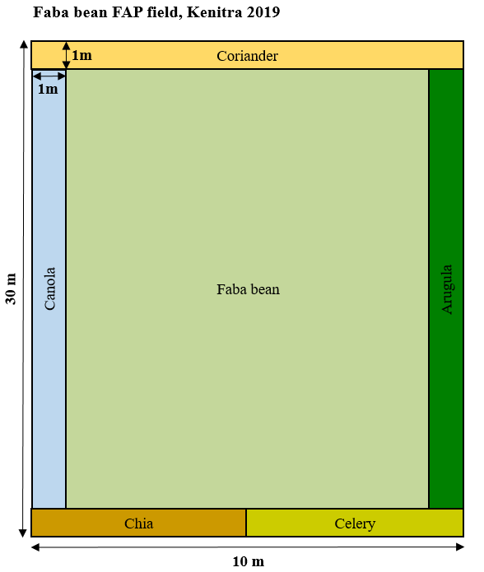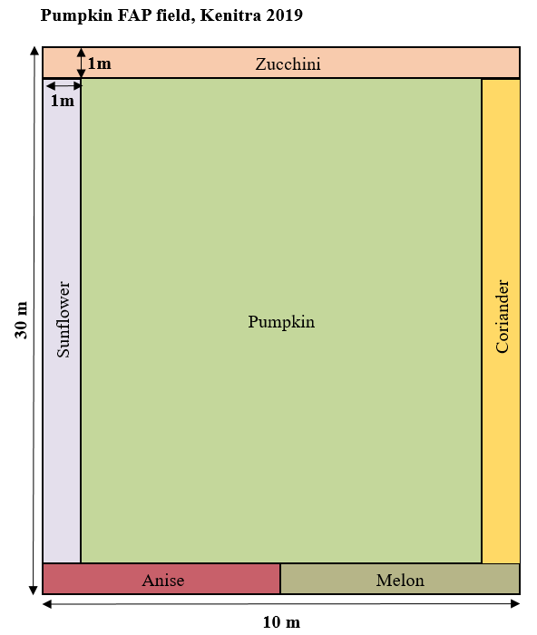
Supplementary Figure 3. Experimental designs of FAP fields (main crop in 75% of the field surrounded by marketable habitat enhancement plants) for each crop in Sefrou in 2018 and 2019
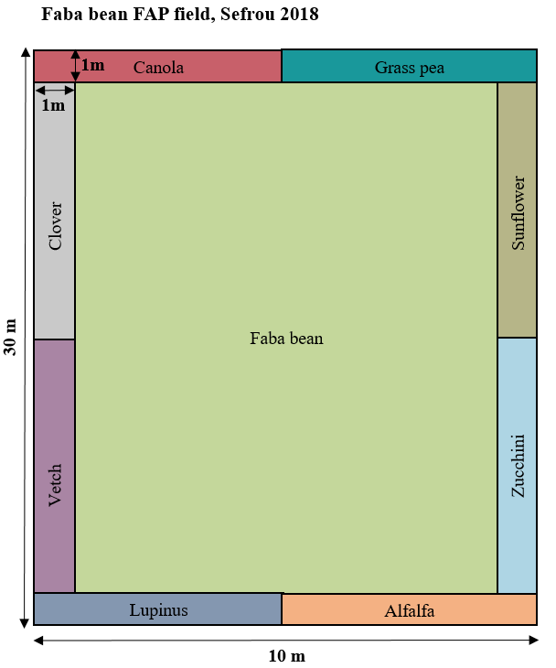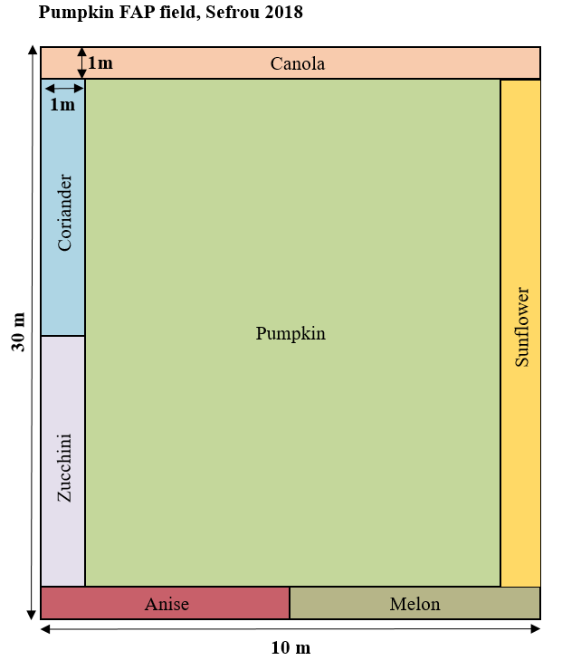
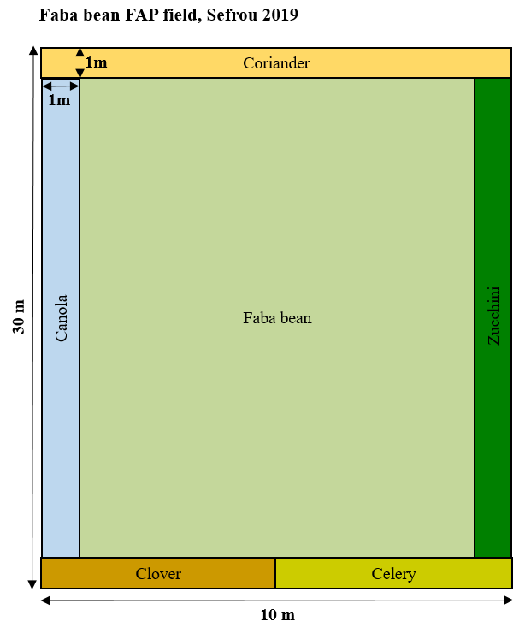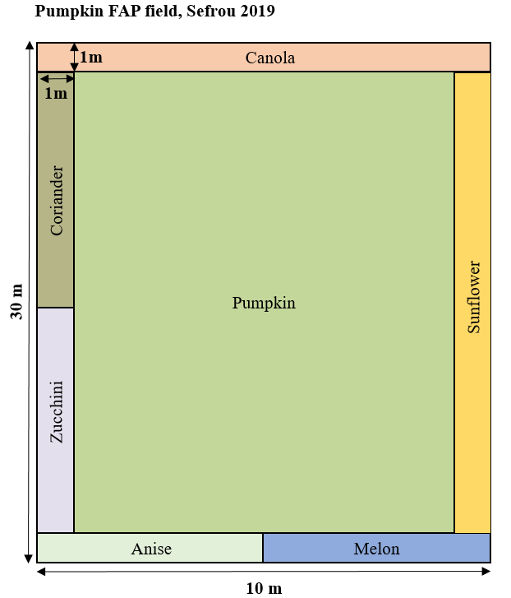

Supplementary Figure 4. Experimental designs of FAP fields (main crop in 75% of the field surrounded by marketable habitat enhancement plants) for each crop in Errachidia in 2019

