Exploration of bioindustrial potential of pure and mixed cultures of purple non sulphur bacteria under photoheterotrophic bacteria
Name: Guillaume Bayon-Vicente*, Manon Gilson*, Ruddy Wattiez and Baptiste Leroy.
*Authors contributed equally to this work.
Affiliation: University of Mons
Purple non-sulfur bacteria are well known for their metabolic versatility as they can grow under both auto-and heterotrophic conditions, phototrophically or not. Moreover, they are able to assimilate a broad range of carbon sources notably volatile fatty acids (VFAs, C1-C5) but also sugars. The PROTMIC lab (UMONS) developed a tremendous expertise in the understanding of metabolic pathways used by PNSB, and more precisely Rhodospirillum rubrum, to assimilate VFAs either pure (one source of carbon) or in mix (several source of carbon). This expertise allowed us to decipher the photoheterotrophic assimilation of different VFAs such as acetic acid, butyric acid or valeric acid.
In that context, our lab investigated the production of polyhydroxyalkanoate by pure culture of Rhodospirillum rubrum cultivated under photoheterotrophic conditions using acetic acid or valeric acid as source of carbon. More precisely we studied the photoheterotrophic metabolism of Rs. rubrum in the here above-mentioned conditions in order to find some tracks for PHA production optimization.
More recently, our lab started analysing the production of protein-rich purple bacteria biomass using bioindustrial co-products as source of carbon. We investigate, currently, at the fundamental (e.g. metabolic pathway, interaction,…) and applied (e.g. protein content, protein quality, productivity,…) point of view the assimilation of molasses by either pure or mix culture of purple bacteria and the impact of different consortia on productivity.
Since more than ten years, PNSB are extensively studied for their bioindustrial applications (e.g. Pigment, PHAs, hydrogen, protein-rich edible biomass, wastewater treatment, …). However, in order for the different bioprocesses to be economically feasible, major optimization are still needed. In that context, two schools of thought are commonly found in the literature, the first one stating that the use of pure culture allows higher process optimization thanks to a better understanding whiled the second one arguing that the use of mix culture brings synergic effects that are a key parameter in process improvement.
Here, we present examples of the application of these two different strategies to increase bioindustrial productivity of PNSB based bioprocesses. First, using pure culture of Rs. rubrum, we succeeded in increasing PHA production in the presence of acetic and valeric acid thanks to a fundamental knowledge-based approach (e.g. literature reviewing, proteomic analyses, growth under different conditions; Figures 1 and 2). Secondly, we observed recently an increased productivity and substrate assimilation efficiency by switching from pure (e.g. Rs rubrum) to mix (Rs.rubrum and Rh. capsulatus) culture (Figure 3).
Figure 1 : Growth (full line; upper panel), acetate consumption (dotted line, upper panel) and PHA accumulation (lower panel) of Rs. rubrum for the acetate-competent strain (A,B) or Wild type strain (C,D) in presence of acetate supplemented with 3 mM HCO3 − submitted (B,D) or not (A,C) to a light intensity increase from 50 to 150 µmol photons/m2 s. Vertical dotted line represents the light stress (B,D) N = 5.
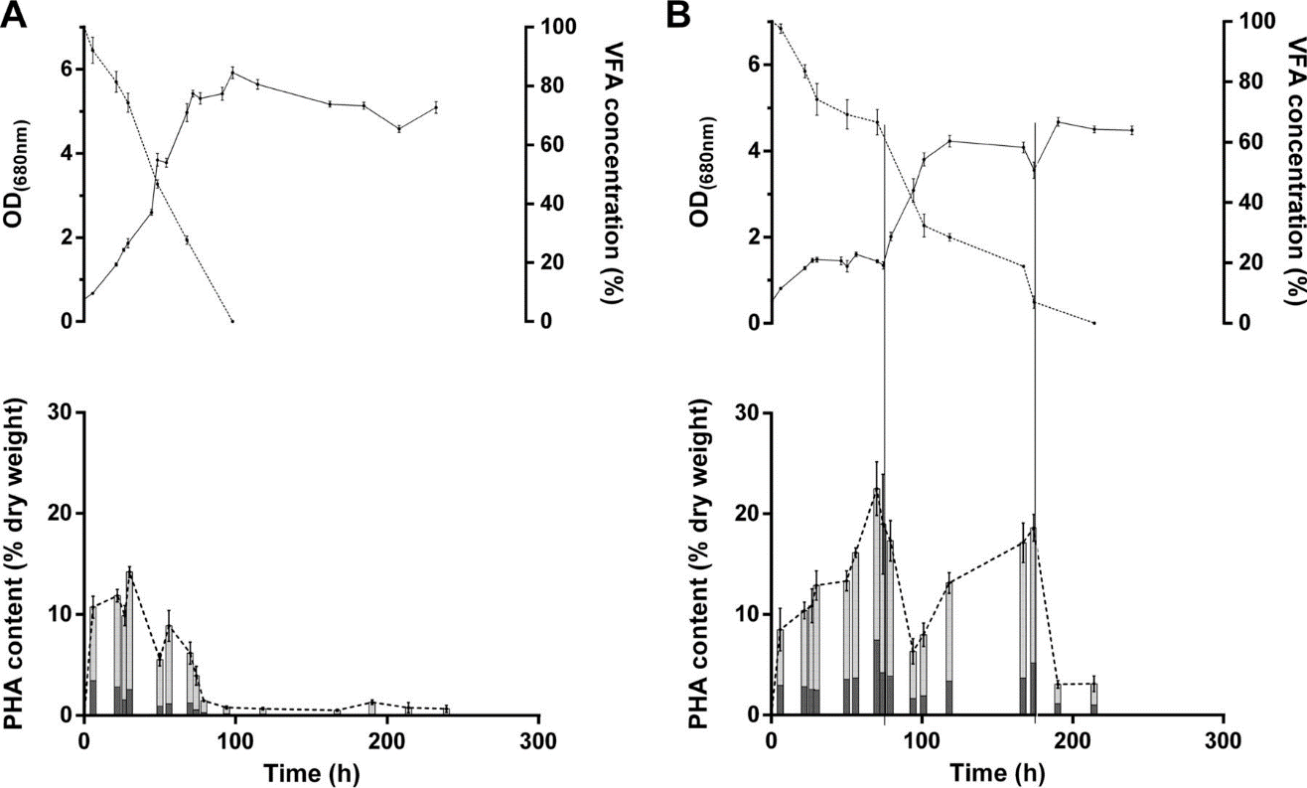
Figure 2 : R. rubrum growth (upper panels [dotted lines represent valerate consumption and solid lines represent growth]) and PHA production (lower panels) observed in the presence of valerate plus 50 mM HCO3 (A) and valerate plus progressive addition of 3 mM bicarbonate ions (vertical lines) (B). 3-Hydroxybutyrate (dark gray) and 3-hydroxyvalerate (light gray) monomer contents were determined by GC-MS analysis (n = 5).

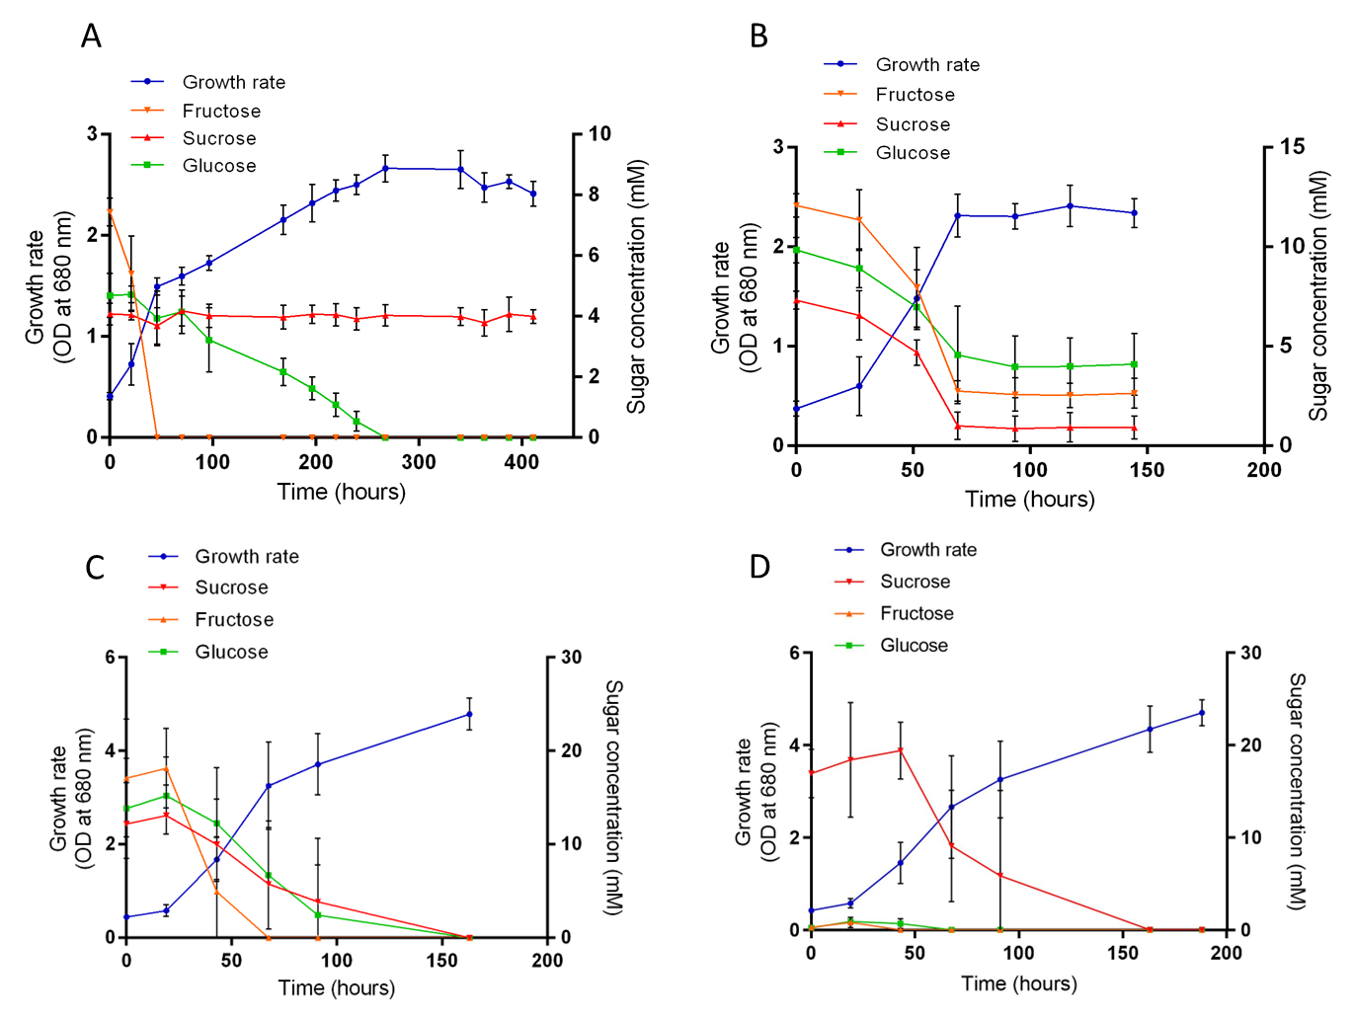
Figure 3 : R. rubrum (A), R. capsulatus (B) and mix culture of R. rubrum and R. capsulatus (C and D) growth under photoheterotrophic conditions in presence of partially hydrolysed (A, B and C) or non-hydrolysed (D) sucrose. N=5.

