Article type: research article
Investigating the influence of the substrate temperature and the organic precursor on the mechanical properties of low pressure plasma polymer films
Robin Dantinne, Nathan Vinx, Philippe Leclère, Damien Cossement, Claude Poleunis, Arnaud Delcorte, Rony Snyders and Damien Thiry *

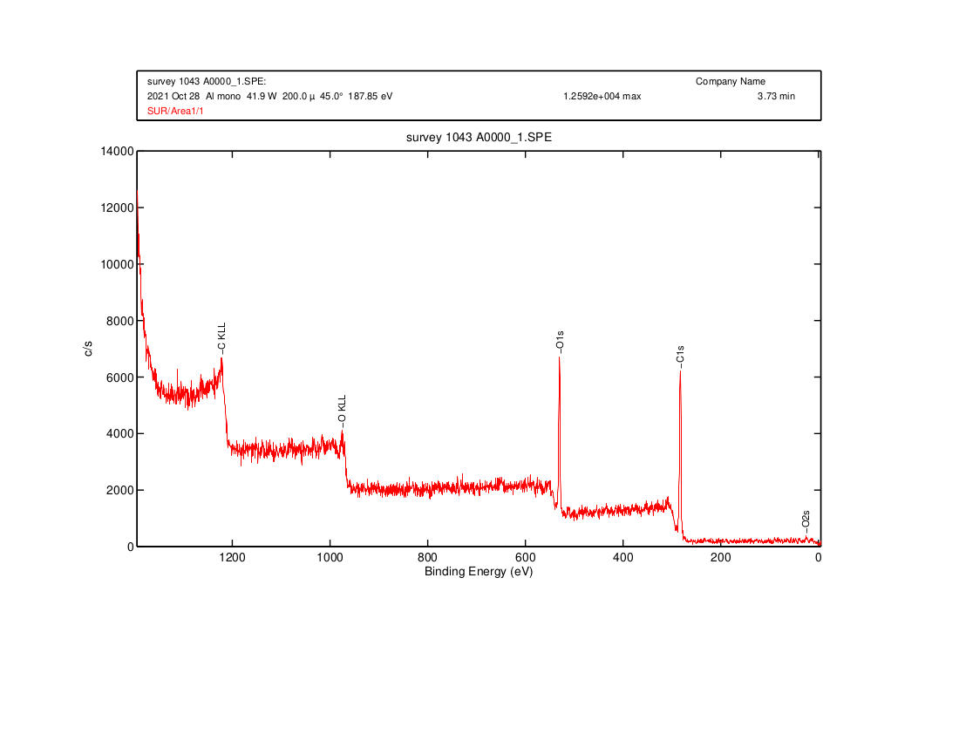
a.
b.

Figure S1: typical XPS spectra of prop-PPF_{10°C} (a) and allyl-PPF_{10°C} (b).

Figure S2: Example of a degradative chain transfer for allyl alcohol.

b.
a.

Figure S3: Typical fitting of a high resolution C1s spectra for a prop-PPF_{10°C} (a) and an allyl-PPF_{10°C} (b).

Figure S4: Positive ToF-SIMS spectra of Allyl-PPF_{23°C}
Table S1a: Most influential negative loadings (statistical weight > 80%) for the PC1 resulting from the PCA analysis of prop-PPF positive ToF-SIMS spectra.

Loadings (PC1 < 0) | Loadings (PC1 < 0)
C₆H₉O⁺ | C₇H₉O₂⁺
C₇H₁₁O⁺ | C₄H₆O₂⁺
C₆H₁₀O⁺ | C₉H₁₃⁺
C₈H₁₃O⁺ | C₄H₅O₂⁺
C₅H₉O₂⁺ | C₅H₇O₂⁺
C₅H₈O⁺ | C₅H₈O₂⁺
C₈H₁₅O⁺ | C₃H₈O⁺
C₅H₁₁O⁺ | C₆H₁₁O⁺
C₉H₁₅O⁺ | C₇H₁₂⁺
C₄H₉O₂⁺ | C₇H₉O⁺
C₄H₆O⁺ | C₆H₁₀⁺
C₃H₇O⁺ | C₁₀H₁₅⁺
C₆H₉O₂⁺ | C₄H₄O₂⁺
C₈H₁₃⁺ | C₆H₇O⁺
C₇H₁₁O₂⁺ | C₈H₁₁O⁺
C₉H₁₇O⁺ | C₆H₁₁⁺
C₇H₁₃O⁺ | C₈H₁₁⁺
C₇H₁₃⁺ | C₅H₆O₂⁺
C₉H₁₅⁺ | C₆H₇O₂⁺
C₄H₇O₂⁺ | C₈H₁₂⁺
C₃H₅O⁺ | C₆H₁₁O₂⁺
C₃H₆O⁺ | C₅H₁₀O⁺
C₃H₅O₂⁺ | C₁₁H₁₇⁺
C₈H₁₄⁺ | C₉H₁₁O⁺
C₆H₁₂O⁺ | C₆H₉⁺
C₇H₁₀O⁺ | C₅H₅O₂⁺
C₇H₁₁⁺ | C₅H₆O⁺
C₆H₈O⁺ | C₂H₅O⁺
C₅H₇O⁺ | C₆H₆O₂⁺
C₆H₁₂⁺

Table S1b: Most influential positive loadings (statistical weight > 80%) for the PC1 resulting from the PCA analysis of prop-PPF positive ToF-SIMS spectra.

Loadings (PC1 > 0) | Loadings (PC1 > 0)
C₃H₅⁺ | C₆H₆⁺
C₂H₃⁺ | C₃H₂⁺
C₄H₃⁺ | C₂H₅⁺
C₃H₆⁺ | C₄H₆⁺
C₂H₄⁺ | C₂H₂⁺
C₃H₄⁺ | C₅H₄⁺
C₄H₄⁺ | C₈H₇⁺
C₃H₃⁺ | C₅H₆⁺
C₅H₅⁺ | C₈H₆⁺
C₄H₂⁺ | C₉H₇⁺
CH₃⁺ | C₇H₉O₃⁺
C₆H₅⁺ | C₇H₇⁺
C₄H₅⁺ | C₇H₁₀O₃⁺
C₅H₃⁺ | CH₂⁺

Table S2a: Most influential negative loadings (statistical weight > 80%) for the PC1 resulting from the PCA analysis of allyl-PPF positive ToF-SIMS spectra.
Loadings (PC1 < 0) | Loadings (PC1 < 0)
C₅H₉⁺ | C₆H₈O⁺
C₃H₈⁺ | C₄H₇⁺
C₇H₉O₂⁺ | C₈H₁₃⁺
C₅H₈O₂⁺ | C₄H₈⁺
C₉H₁₅⁺ | C₇H₈⁺
C₆H₁₂O⁺ | C₅H₈⁺
C₅H₃O⁺ | C₅H₇⁺
C₁₀H₁₁⁺ | C₉H₁₃⁺
C₅H₈O⁺ | C₈H₉⁺
C₅H₁₀⁺ | C₉H₁₁⁺
C₆H₆O⁺ | C₈H₁₁O⁺
C₁₀H₁₅⁺ | C₇H₁₂⁺
C₇H₇⁺ | C₈H₁₄⁺
C₃H₇O₂⁺ | C₆H₇⁺
C₉H11_{O}⁺ | C₆H₁₀⁺
C₆H₆⁺ | C₆H₈⁺
C₅H₆⁺ | C₇H₁₀⁺
C₆H₁₂⁺ | C₇H₁₀O⁺
C₄H₆O⁺ | C₈H₁₂⁺
C₈H₈⁺ | C₆H₉⁺
C₆H₁₀O⁺ | C₈H₁₁⁺
C₇H₈O⁺ | C₇H₁₁⁺
C₈H₁₃O⁺ | C₈H₁₀⁺
C₁₀H₁₃⁺ | C₇H₉⁺
.
Table S2b: Most influential positive loadings (statistical weight > 80%) for the PC1 resulting from the PCA analysis of allyl-PPF positive ToF-SIMS spectra.
Loadings (PC1 > 0) | Loadings (PC1 > 0)
C₄H₃O₂⁺ | C₅H₂⁺
C₃H₃O⁺ | C₂H₃O₂⁺
C₃HO₂⁺ | C₆H₇O₂⁺
CH₂⁺ | CH₃⁺
C₂H₅⁺ | C₃H₄O₂⁺
C₄H₅O⁺ | C₂H₄O⁺
C₆H₉O₂⁺ | CH₂O⁺
C₃H₃O₂⁺ | C₇H₃⁺
H⁺ | C₂H₃⁺
C₂H₃O⁺ | C₇H₁₃O⁺
C₂H₂⁺ | CH₅O₂⁺
C₅H₇O⁺ | C₄H⁺
C₅H₅O⁺ | C₇H₂⁺
C₅H₅O₂⁺ | C₆H₂⁺
CHO⁺ | CH⁺
C₂H₂O⁺ | C₆H₇O⁺
C₃H₂⁺ | C₄H₂⁺
C₃HO⁺ | C⁺
CH₃O⁺ | C₆H₃⁺
C₃H₄O⁺ | H₂⁺
C₆H₅O₂⁺ | C₄H₃O⁺

