Molecular Modeling of Single-Chain Nanoparticles as Enzyme Mimetics

David Dellemme¹, Stefan Wijker², Anja Palmans² and Mathieu Surin¹

- Laboratory for Chemistry of Novel Materials, Center for Innovation in Materials and Polymers, University of Mons - UMONS, 20 Place du Parc, B-7000 Mons, Belgium.
- Laboratory of Macromolecular and Organic Chemistry, Institute for Complex Molecular Systems, Department of Chemical Engineering and Chemistry, Eindhoven University of Technology, P.O. Box 513, 5600 MB Eindhoven, The Netherlands.

Biomacromolecules constitute a source of inspiration for chemists, being highly functional and specific nanomaterials. Enzymes, for example, display very selective catalytic properties through a perfectly-controlled folding in water. In the past decades, researchers created enzyme mimetic macromolecules, designed to reproduce the main characteristics of the active site of a targeted enzyme.¹ In this context, the field of Single-Chain Polymeric Nanoparticles (SCPNs) is emerging and chemists seek to design systems with specific functions through their collapse in solution, such as catalysis.² These synthetic systems are based on simpler yet similar network of interactions than their biomacromolecular counterparts, exploiting essentially solvophilic/solvophobic effects and supramolecular interactions.³

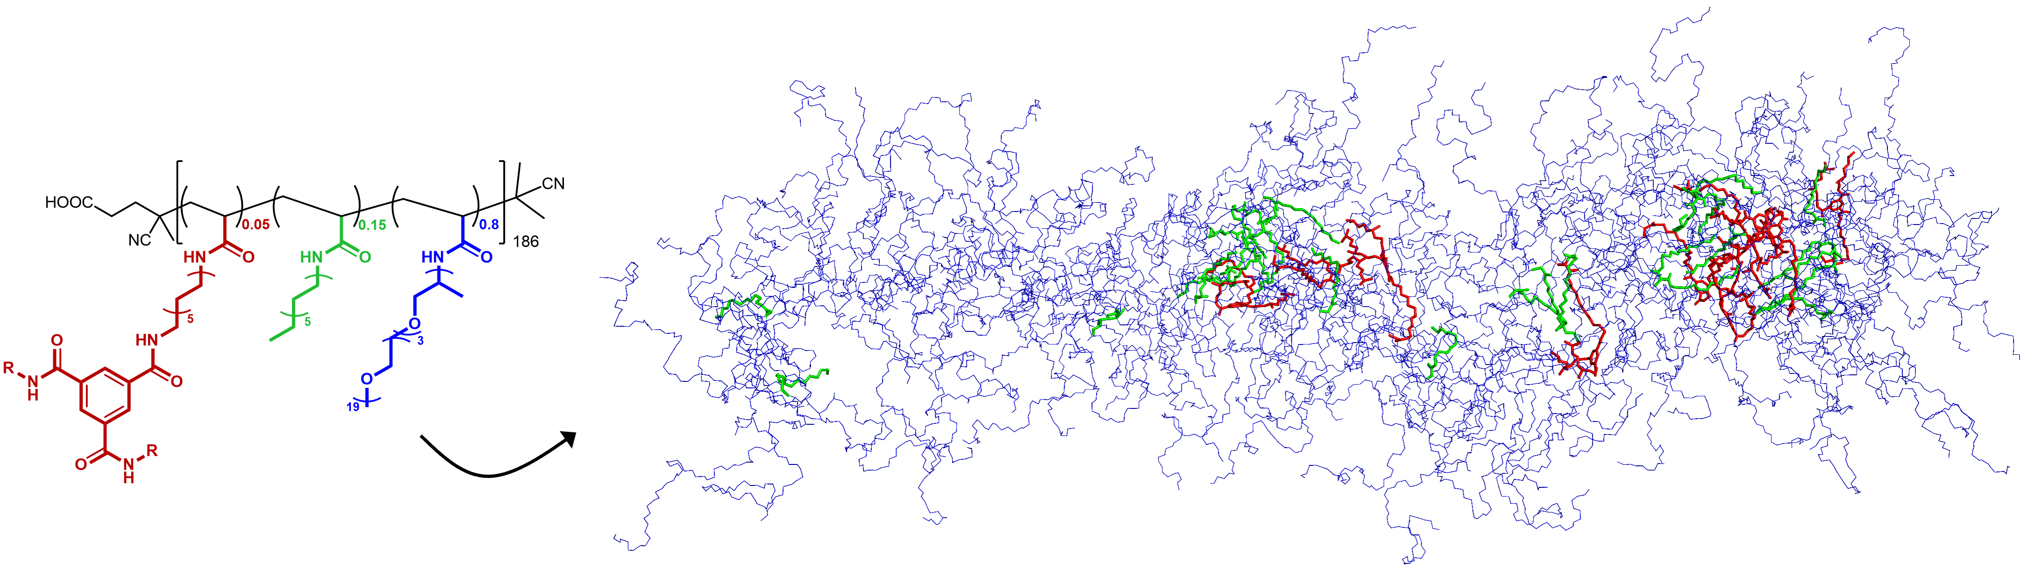
Here, we study and compare two SCPNs: a fully hydrophilic homopolymer, and a copolymer constituted of different substituents (hydrophilic, hydrophobic, and supramolecular units). These two SCPNs are studied by means of all-atom molecular dynamics (MD) simulations, a powerful tool to get insights into the 3D structures and dynamics of such complex systems.⁴ Different computational parameters are tested and the structures obtained from MD simulations are compared to experimental data, especially small-angle X-ray scattering (SAXS) spectra. We show that the charge distribution used in MD simulations is crucial and that a careful validation against experimental measurements is mandatory. The combination of MD and SAXS data provides a detailed molecular picture of SCPNs, which is useful for a rational design of enzyme-mimetic systems.

References

- M. D. Nothling, Z. Xiao, A. Bhaskaran, M. T. Blyth, C. W. Bennett, M. L. Coote, L. A. Connal, ACS Catal. 2019, 9, 168-187.
- F. Eisenreich, E. W. Meijer, A. R. A. Palmans, Chem. Eur. J. 2020, 26, 10355-10361.
- G. M. ter Huurne, A. R. A. Palmans, E. W. Meijer, CCS Chem. 2019, 1, 64-82.
- S. L. Hilburg, Z. Ruan, T. Xu, A. Alexander-Katz, Macromolecules 2020, 53, 9187-9199.

