Ni²⁺ removal by ion exchange resins and activated carbon: a benchtop NMR study.

Table S1 Proton relaxivities of Ni²⁺ in water at 22°C
Magnetic Field (T) | r₁ (s⁻¹ mM⁻¹) | r₂ (s⁻¹ mM⁻¹)
0.23 | 0.64 ± 0.03 | 0.67 ± 0.03
0.47 | 0.6 ± 0.02 | 0.64 ± 0.03
0.68 | 0.56 ± 0.02 | 0.58 ± 0.02
Table S2 The binding energy results of C1s, O1s, S2p and Ni2p spectra for adsorbents before and after Ni²⁺ loading
Sample | Component | Binding energy /eV | FWHM /eV | Concentration /at.%
IR120 | Na KLL | 536.62 ± 0.04 | 2.38 ± 0.11
 | O 1s C-O | 533.18 ± 0.04 | 1.38 ± 0.01 | 1.96 ± 0.16
 | O 1s S=O | 531.69 ± 0.01 | 1.38 ± 0.01 | 18.59 ± 0.74
 | C 1s Shake-up 2 | 290.96 ± 0.23 | 1.42 ± 0.42 | 1.17 ± 0.22
 | C 1s Shake-up 1 | 288.44 ± 0.24 | 2.97 ± 0.76 | 2.89 ± 0.9
 | C 1s C-O | 286.46 ± 0.02 | 1.01 ± 0.02 | 2.27 ± 0.22
 | C 1s C-SO3 | 285.3 ± 0.02 | 1.01 ± 0.02 | 7.94 ± 0.74
 | C 1s C-C | 284.64 ± 0.01 | 1.01 ± 0.02 | 50.85 ± 2.9
 | S 2p Sulfonic acid 1/2 | 169.26 ± 0.0 | 1.02 ± 0.01 | 2.6 ± 0.09
 | S 2p Sulfonic acid 3/2 | 168.07 ± 0.0 | 1.02 ± 0.01 | 5.2 ± 0.18
IR120 + Ni | Ni 2p 3/2 Ni(OH)2 6 | 867.54 ± 0.01 | 3.49 ± 0.12 | 0.03 ± 0.01
 | Ni 2p 3/2 NiO 5 | 866.23 ± 0.05 | 2.32 ± 0.62 | 0.01 ± 0.0
 | Ni 2p 3/2 NiO 4 | 863.85 ± 0.05 | 1.94 ± 0.51 | 0.01 ± 0.01
 | Ni 2p 3/2 Ni(OH)2 5 | 862.58 ± 0.01 | 5.39 ± 0.19 | 0.37 ± 0.07
 | Ni 2p 3/2 Ni(OH)2 4 | 861.58 ± 0.01 | 1.23 ± 0.05 | 0.01 ± 0.01
 | Ni 2p 3/2 NiO 3 | 860.75 ± 0.05 | 3.57 ± 0.94 | 0.06 ± 0.01
 | Ni 2p 3/2 Ni(OH)2 3 | 858.79 ± 0.01 | 1.84 ± 0.07 | 0.03 ± 0.01
 | Ni 2p 3/2 Ni(OH)2 2 | 856.77 ± 0.01 | 2.65 ± 0.09 | 0.42 ± 0.08
 | Ni 2p 3/2 Ni(OH)2 1 | 856.0 ± 0.01 | 1.35 ± 0.05 | 0.07 ± 0.01
 | Ni 2p 3/2 NiO 2 | 855.31 ± 0.05 | 3.09 ± 0.82 | 0.08 ± 0.02
 | Ni 2p 3/2 NiO 1 | 853.6 ± 0.05 | 0.97 ± 0.26 | 0.03 ± 0.01
 | Na KLL | 536.64 ± 0.04 | 2.55 ± 0.05 | nan ± nan
 | O 1s C-O | 533.24 ± 0.02 | 1.5 ± 0.03 | 3.56 ± 0.66
 | O 1s S=O | 531.76 ± 0.03 | 1.5 ± 0.03 | 16.02 ± 0.58
 | C 1s Shake-up 2 | 290.97 ± 0.2 | 1.09 ± 0.31 | 0.59 ± 0.25
 | C 1s Shake-up 1 | 288.44 ± 0.12 | 2.12 ± 0.45 | 3.94 ± 1.15
 | C 1s C-O | 286.49 ± 0.06 | 1.08 ± 0.04 | 4.17 ± 0.68
 | C 1s C-SO3 | 285.37 ± 0.08 | 1.08 ± 0.04 | 9.69 ± 2.52
 | C 1s C-C | 284.62 ± 0.04 | 1.08 ± 0.04 | 53.18 ± 4.57
 | S 2p Sulfonic acid 1/2 | 169.25 ± 0.01 | 1.15 ± 0.02 | 1.83 ± 0.15
 | S 2p Sulfonic acid 3/2 | 168.06 ± 0.02 | 1.15 ± 0.02 | 3.66 ± 0.31
Marathon MSC | O 1s HO-S | 533.71 ± 0.04 | 1.39 ± 0.01 | 6.51 ± 0.23
 | O 1s O=S | 532.32 ± 0.02 | 1.39 ± 0.01 | 16.15 ± 0.1
 | C 1s Shake-up 2 | 290.73 ± 0.19 | 2.77 ± 0.19 | 3.77 ± 0.6
 | C 1s C-O | 286.89 ± 0.11 | 1.08 ± 0.02 | 1.56 ± 0.05
 | C 1s C-SO3 | 285.58 ± 0.15 | 1.08 ± 0.02 | 6.3 ± 2.2
 | C 1s C-C | 284.74 ± 0.02 | 1.08 ± 0.02 | 55.85 ± 1.55
 | S 2p Sulfonic acid 1/2 | 169.97 ± 0.02 | 1.09 ± 0.0 | 3.03 ± 0.08
 | S 2p Sulfonic acid 3/2 | 168.77 ± 0.02 | 1.09 ± 0.0 | 6.05 ± 0.17
Marathon MSC+ Ni | O 1s HO-S | 533.69 ± 0.03 | 1.39 ± 0.01 | 6.25 ± 0.07
 | O 1s O=S | 532.32 ± 0.03 | 1.39 ± 0.01 | 16.36 ± 0.2
 | C 1s Shake-up 2 | 290.93 ± 0.02 | 2.22 ± 0.03 | 3.34 ± 0.15
 | C 1s C-O | 286.91 ± 0.09 | 1.07 ± 0.02 | 1.52 ± 0.19
 | C 1s C-SO3 | 285.55 ± 0.06 | 1.07 ± 0.02 | 5.93 ± 0.88
 | C 1s C-C | 284.76 ± 0.03 | 1.07 ± 0.02 | 56.87 ± 0.98
 | S 2p Sulfonic acid 1/2 | 169.96 ± 0.03 | 1.14 ± 0.01 | 3.12 ± 0.07
 | S 2p Sulfonic acid 3/2 | 168.76 ± 0.03 | 1.14 ± 0.01 | 6.24 ± 0.13
IRC748 | Na KLL | 535.82 ± 0.06 | 2.86 ± 0.43
 | O 1s C-O | 532.81 ± 0.03 | 1.44 ± 0.02 | 2.82 ± 1.13
 | O 1s C=O, NaO-C | 531.34 ± 0.04 | 1.44 ± 0.02 | 13.62 ± 0.35
 | N 1s C-N+ | 402.01 ± 0.02 | 1.39 ± 0.04 | 0.53 ± 0.11
 | N 1s C-N | 399.39 ± 0.01 | 1.39 ± 0.04 | 3.46 ± 0.2
 | C 1s Shake-up 1 | 290.18 ± 0.14 | 3.7 ± 0.63 | 3.93 ± 0.7
 | C 1s O-C=O | 288.29 ± 0.01 | 1.1 ± 0.01 | 6.54 ± 0.21
 | C 1s C-O | 286.68 ± 0.04 | 1.1 ± 0.01 | 3.97 ± 0.13
 | C 1s C-N | 285.66 ± 0.03 | 1.1 ± 0.01 | 13.67 ± 0.32
 | C 1s C-C | 284.7 ± 0.0 | 1.1 ± 0.01 | 41.94 ± 2.97
IRC748 Ni | Ni 2p 3/2 Ni(OH)2 6 | 866.71 ± 0.08 | 2.23 ± 0.31 | 0.02 ± 0.02
 | Ni 2p 3/2 NiO 5 | 866.2 ± 0.37 | 2.05 ± 0.35 | 0.0 ± 0.01
 | Ni 2p 3/2 NiO 4 | 863.81 ± 0.36 | 1.72 ± 0.29 | 0.0 ± 0.01
 | Ni 2p 3/2 Ni(OH)2 5 | 861.75 ± 0.08 | 3.45 ± 0.48 | 0.26 ± 0.18
 | Ni 2p 3/2 Ni(OH)2 4 | 860.75 ± 0.08 | 0.79 ± 0.11 | 0.01 ± 0.01
 | Ni 2p 3/2 NiO 3 | 860.72 ± 0.37 | 3.16 ± 0.53 | 0.04 ± 0.04
 | Ni 2p 3/2 Ni(OH)2 3 | 857.96 ± 0.08 | 1.18 ± 0.17 | 0.02 ± 0.02
 | Ni 2p 3/2 Ni(OH)2 2 | 855.94 ± 0.08 | 1.7 ± 0.24 | 0.3 ± 0.21
 | Ni 2p 3/2 NiO 2 | 855.27 ± 0.36 | 2.73 ± 0.47 | 0.05 ± 0.05
 | Ni 2p 3/2 Ni(OH)2 1 | 855.17 ± 0.08 | 0.86 ± 0.12 | 0.05 ± 0.03
 | Ni 2p 3/2 NiO 1 | 853.56 ± 0.36 | 0.86 ± 0.15 | 0.02 ± 0.02
 | Na KLL | 536.18 ± 0.27 | 2.52 ± 0.16 | nan ± nan
 | O 1s C-O | 532.96 ± 0.15 | 1.63 ± 0.13 | 8.24 ± 6.03
 | O 1s C=O, MO-C | 531.61 ± 0.2 | 1.63 ± 0.13 | 13.35 ± 2.33
 | N 1s NO3 | 407.29 ± 0.41 | 1.62 ± 0.08 | 1.13 ± 0.87
 | N 1s C-N+ | 402.47 ± 0.21 | 1.62 ± 0.08 | 0.32 ± 0.05
 | N 1s C-N | 399.73 ± 0.2 | 1.62 ± 0.08 | 3.26 ± 0.92
 | C 1s Shake-up 1 | 290.19 ± 0.4 | 3.49 ± 0.79 | 3.38 ± 0.83
 | C 1s O-C=O | 288.31 ± 0.12 | 1.12 ± 0.04 | 5.09 ± 2.68
 | C 1s C-O | 286.7 ± 0.21 | 1.12 ± 0.04 | 6.1 ± 4.15
 | C 1s C-N | 285.77 ± 0.06 | 1.12 ± 0.04 | 12.85 ± 1.02
 | C 1s C-C | 284.7 ± 0.0 | 1.12 ± 0.04 | 39.24 ± 4.42
AC | O 1s HO-C=O | 535.66 ± 0.42 | 2.33 ± 0.15 | 0.68 ± 0.21
 | O 1s O-C | 533.48 ± 0.23 | 2.33 ± 0.15 | 6.84 ± 2.96
 | O 1s O=C | 531.73 ± 0.13 | 2.33 ± 0.15 | 1.79 ± 0.25
 | C 1s Shake-up | 290.47 ± 0.03 | 4.74 ± 0.09 | 10.39 ± 1.28
 | C 1s C-O | 286.39 ± 0.14 | 0.9 ± 0.24 | 0.52 ± 0.15
 | C 1s C-C | 284.5 ± 0.0 | 0.92 ± 0.01 | 76.22 ± 3.69
 | S 2p Sulfonate, sulfate 1/2 | 169.49 ± 0.19 | 1.6 ± 0.17 | 0.06 ± 0.01
 | S 2p Sulfonate, sulfate 3/2 | 168.33 ± 0.19 | 1.6 ± 0.17 | 0.11 ± 0.02
 | S 2p Disulfide, thiol, sulfur 1/2 | 165.1 ± 0.07 | 1.6 ± 0.17 | 0.05 ± 0.01
 | S 2p Disulfide, thiol, sulfur 3/2 | 163.94 ± 0.07 | 1.6 ± 0.17 | 0.1 ± 0.03
AC 650°C | O 1s HO-C=O | 535.68 ± 0.4 | 2.49 ± 0.13 | 0.54 ± 0.16
 | O 1s O-C | 533.45 ± 0.1 | 2.49 ± 0.13 | 4.9 ± 1.41
 | O 1s O=C | 531.55 ± 0.13 | 2.49 ± 0.13 | 1.25 ± 0.1
 | C 1s Shake-up | 290.53 ± 0.1 | 4.27 ± 0.17 | 9.57 ± 1.24
 | C 1s C-O | 286.49 ± 0.24 | 0.63 ± 0.17 | 0.42 ± 0.29
 | C 1s C-C | 284.5 ± 0.0 | 0.91 ± 0.01 | 80.96 ± 2.51
 | S 2p Disulfide, thiol, sulfur 1/2 | 165.13 ± 0.01 | 1.06 ± 0.1 | 0.09 ± 0.01
 | S 2p Disulfide, thiol, sulfur 3/2 | 163.97 ± 0.01 | 1.06 ± 0.1 | 0.19 ± 0.02
AC 650°C +Ni | Ni 2p 3/2 Ni(OH)2 6 | 867.18 ± 0.13 | 3.48 ± 0.05 | 0.07 ± 0.02
 | Ni 2p 3/2 Ni(OH)2 5 | 862.22 ± 0.13 | 5.38 ± 0.08 | 0.77 ± 0.21
 | Ni 2p 3/2 Ni(OH)2 4 | 861.22 ± 0.13 | 1.23 ± 0.02 | 0.03 ± 0.01
 | Ni 2p 3/2 Ni(OH)2 3 | 858.43 ± 0.13 | 1.84 ± 0.03 | 0.06 ± 0.02
 | Ni 2p 3/2 Ni(OH)2 2 | 856.41 ± 0.13 | 2.65 ± 0.04 | 0.88 ± 0.24
 | Ni 2p 3/2 Ni(OH)2 1 | 855.64 ± 0.13 | 1.34 ± 0.02 | 0.14 ± 0.04
 | O 1s HO-C=O | 534.78 ± 0.34 | 1.98 ± 0.11 | 0.85 ± 0.26
 | O 1s O-C | 533.01 ± 0.19 | 1.98 ± 0.11 | 3.66 ± 0.23
 | O 1s O=C, Ni(OH)2 | 531.42 ± 0.13 | 1.98 ± 0.11 | 5.69 ± 1.04
 | C 1s Shake-up | 290.43 ± 0.18 | 4.44 ± 0.38 | 9.1 ± 1.1
 | C 1s C-O | 286.49 ± 0.29 | 0.58 ± 0.07 | 0.2 ± 0.23
 | C 1s C-C | 284.5 ± 0.0 | 0.91 ± 0.01 | 77.18 ± 1.61
 | S 2p Disulfide, thiol, sulfur 1/2 | 165.1 ± 0.03 | 1.03 ± 0.1 | 0.06 ± 0.02
 | S 2p Disulfide, thiol, sulfur 3/2 | 163.94 ± 0.03 | 1.03 ± 0.1 | 0.12 ± 0.03

Table S3 Effect of AC thermal activation on Ni²⁺ adsorption at 0.68T and at 20°C
 | Nickel concentration (mM) | AC amount (mg) | q (mg_{Ni}/g_{AC}) | Adsortpion rate (%)
Commercial AC | 5 | 20 | 1.01 ± 0.19 | 19.7 ± 3.7
AC after heating at 650°C | 5 | 20 | 5.03 ± 0.03 | 98.12 ± 0.6
Commercial AC | 50 | 20 | 3.03 ± 1.9 | 5.9 ±3.8
AC after heating at 650°C | 50 | 20 | 8.83 ± 1.7 | 18.38 ± 3.3

Table S4 Elemental composition of Adsorbents before and after Ni²⁺ loading
 |  |  | Element abundance %
Element |  | IR120 |  | IR120 after Ni²⁺ loading | IRC748 | IRC748 after Ni²⁺ loading | Marathon MSC | Marathon MSC after Ni²⁺ loading | AC | AC after Ni²⁺ loading
C | 29.7 |  |  | 29.4 | 53.9 | 59.6 | 41.1 | 38.0 | 64.9 | 65.5
O | 36.3 |  |  | 35.4 | 39.5 | 19.3 | 36.6 | 40.7 | 13.7 | 19.2
Na | 14.9 |  |  | 8.9 | 6.2 | 11.4 | / | / | / | /
Si | / |  |  | / | / | / | / | / | 7.7 |  | 1.4
S | 18.8 |  |  | 18.6 | / | / | 22.2 | 16.6 | 2.9 |  | 0.8
Au | / |  |  | / | / | / | / | / | 10.2 |  | 9.5
Ni | 0.2 |  |  | 7.7 | 0.4 | 9.7 | 0.1 | 4.8 | 0.6 | 3.6

Table S5 Relaxation times of resin loaded with and without filtration by centrifugation at 0.47 T and at 22°C
Adsorbent | With filtration |  | without filtration
 | T₁ (ms) | T₂ (ms) | T_{1, fast} (ms) | T_{2, fast} (ms)
IR120 | 3.60 ± 0.14 | 3.03 ± 0.12 | 4.00 ± 0.16 | 3.10 ± 0.12
Dowex | 33.0 ± 1.3 | 28.0 ± 1.1 | 42.0 ± 1.7ª | 32.0 ± 1.3ª
IRC748 | 120.7 ± 4.8 | 11.5 ± 0.5 | 124 ± 5ª | 13.8 ± 0.6ª
ª measured at 0.23T

Table S6 Results of the fitting with an empirical law of the dependence of the fast relaxation rates of the wet resins with the actual Ni²⁺ content measured by ICP AES/MS
 |  | a (s⁻¹ g_{sorb} mg_{Ni}^{-n}) | B (s⁻¹) | n | R²
 |  |  |  | x 10⁻²
Amberlite IR120 | T₁ | 7.4 ± 3.5 | 16 ± 12 | 1.14 ± 0.13 | 0.99
 | T₂ | 10.1 ± 3.1 | 16 ± 10 | 1.1 ± 0.09 | 1
Amberlite IRC748 | T₁ | 0.36 ± 0.1 | 5.86 ± 0.13 | 84 ± 10 | 0.99
 | T₂ | 0.9 ± 1.1 | 65.5 ± 1.6 | 95 ± 45 | 0.92
Dowex Marathon MSC | T₁ | 7.06 ± 0.45 | 5.12 ± 0.36 | 1.075 ± 0.041 | 1
 | T₂ | 6.94 ± 0.50 | 7.4 ± 0.41 | 1.18 ± 0.047 | 1

Table S7 Surface relaxivities of AC for different Ni²⁺ loadings
q_{ICP} (mg_{Ni}/g_{AC}) | ρ₁ (µm s⁻¹) | ρ₂ (µm s⁻¹)
0.02 | 0.029 ± 0.003 | 0.128 ± 0.01
2.46 | 0.031 ± 0.003 | 0.12 ± 0.01
4.82 | 0.031 ± 0.003 | 0.148 ± 0.01
6.61 | 0.041 ± 0.004 | 0.196 ± 0.02
7.88 | 0.046 ± 0.005 | 0.193 ± 0.02
8.51 | 0.048 ± 0.005 | 0.197 ± 0.02
10.06 | 0.063 ± 0.006 | 0.244 ± 0.02
10.55 | 0.067 ± 0.007 | 0.28 ± 0.03

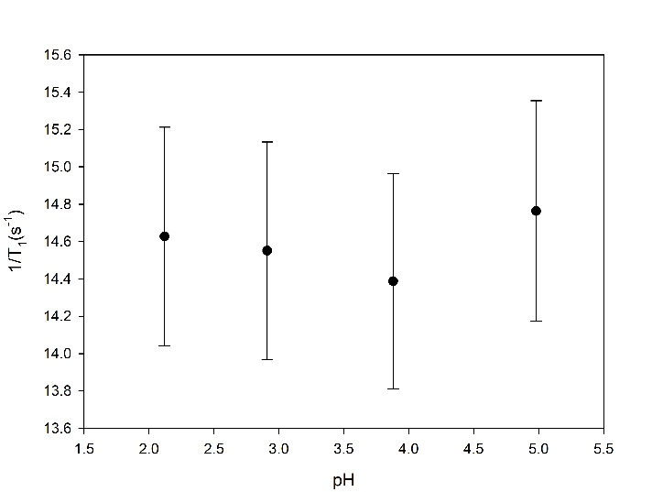

Fig. S1 Effect of pH on the longitudinal relaxation rates at 0.47 T and 20°C for 25mM Ni²⁺ solution

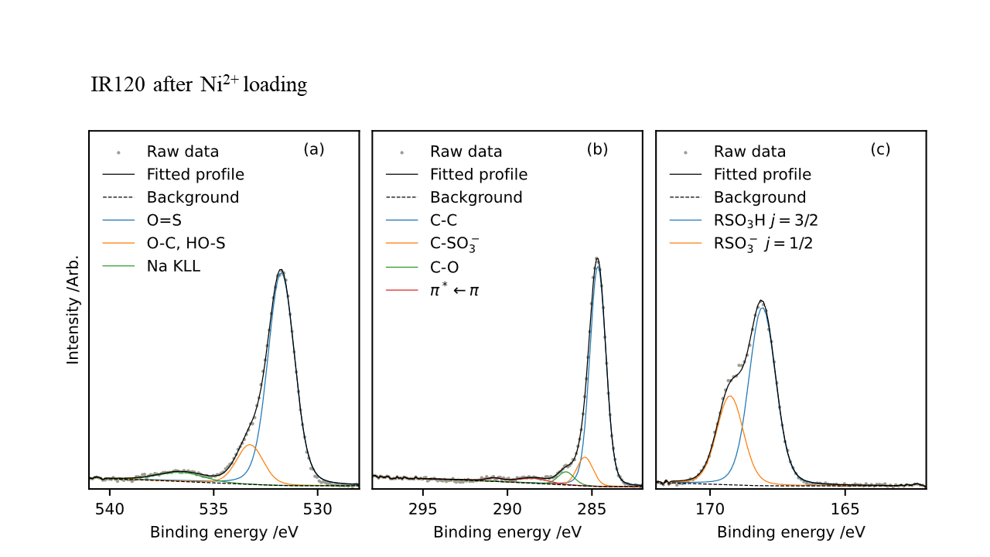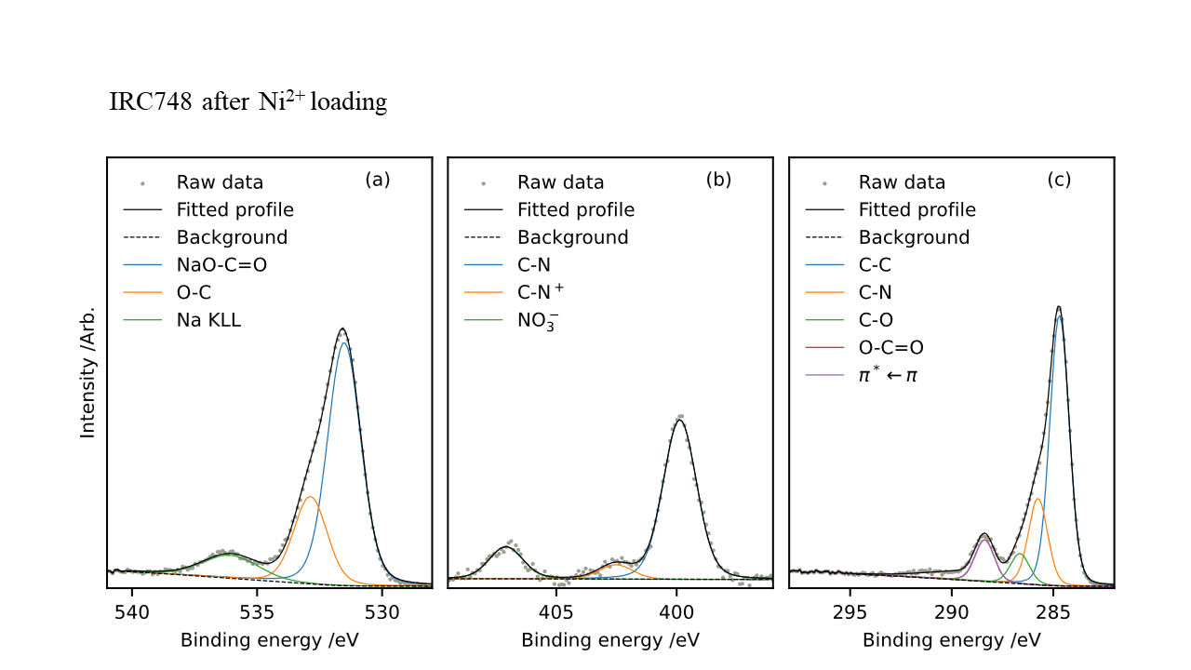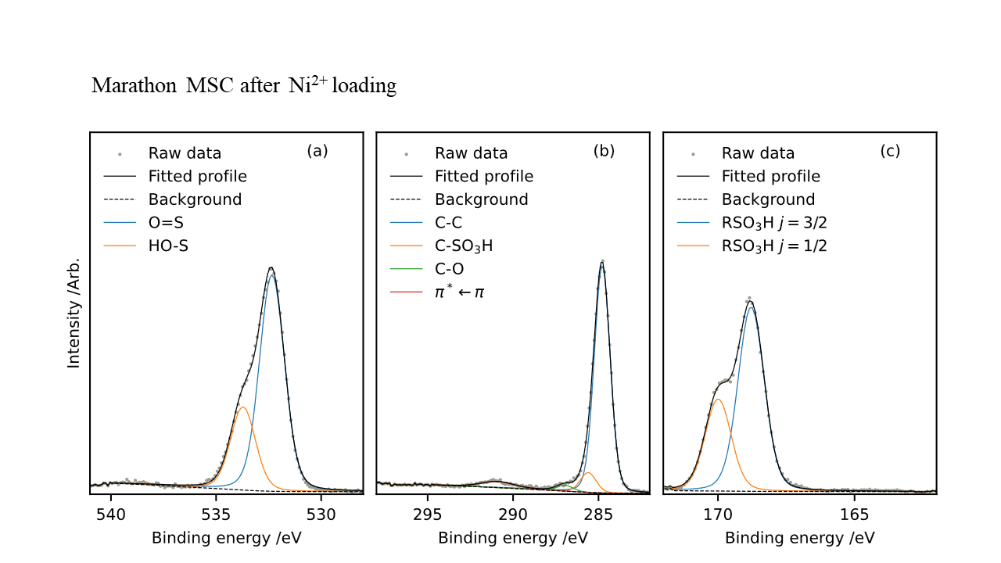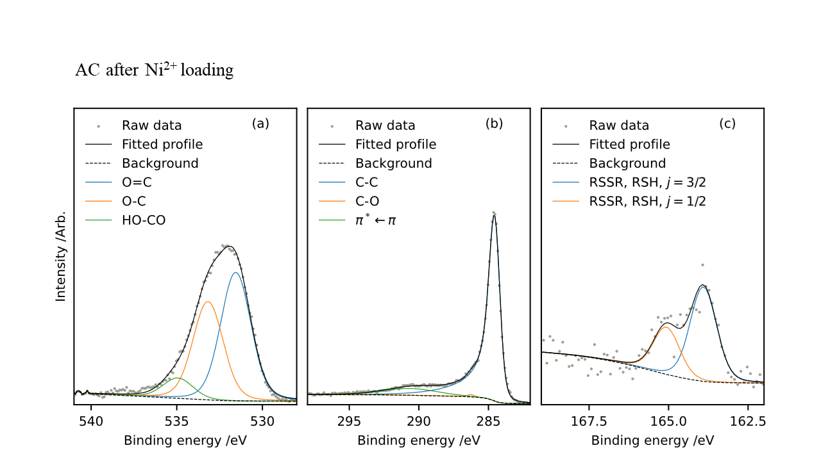
Fig. S2 O 1s (a), C 1s (b) and S 2p (c) XPS spectra of adsorbents after Ni²⁺ loading

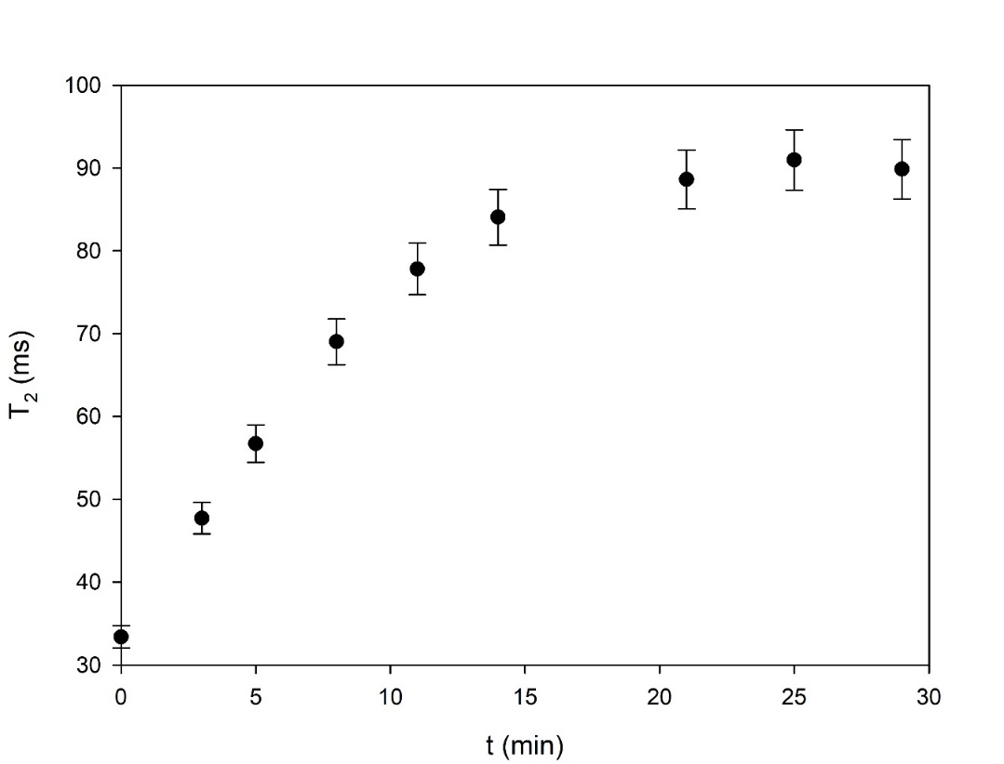
Fig. S3 Evolution of the transverse relaxation time (T₂) with time during the adsorption of Ni²⁺ on Amberlite IR120

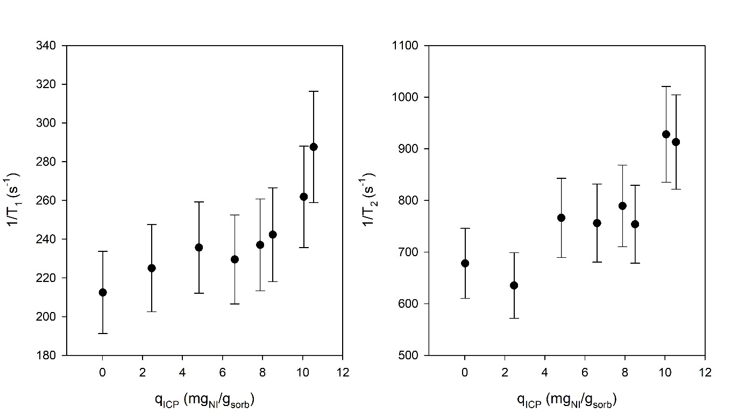
Fig. S4 Effect of Ni²⁺ content on the fast relaxation rates of the activated carbon after filtration by centrifugation

