Supporting Information

NMR relaxometry to monitor in situ the loading of Amberlite IR120 and Dowex Marathon MSC resins with Ni²⁺ and Cu²⁺ during a column experiment

Marie Bernardiª, Rodrigo De Oliveira-Silva^{b}, Quoc Lam Vuongª, Dimitrios Sakellariou^{b}, Yves Gossuinª
ªBiomedical Physics Unit, Research Institute for Materials Science and Engineering, UMONS, 25 avenue Maistriau, 7000 Mons, Belgium
^{b}Centre for Membrane Separations, Adsorption, Catalysis and Spectroscopy (cMACS), KU Leuven, 200 F Box 2454 Celestijnenlaan, 3001 Leuven, Belgium
Corresponding author: Yves Gossuin, yves.gossuin@umons.ac.be

Figure S1: Evolution of the amplitude A_{fast} of the fast fraction obtained by the biexponential fitting of the relaxation curves during a column experiment with IR120 resin and a 20 mM Ni²⁺ solution. m_{resin} = 14 g, flow rate = 4.3 ml/min.

Figure S2: Evolution of the relaxation rate 1/T_{2,fast} of the fast fraction obtained by the biexponential fitting of the relaxation curves during a column experiment with IR120 resin and a 20 mM Ni²⁺ solution. m_{resin} = 14 g, flow rate = 4.3 ml/min.

Figure S3: Evolution with time of the amplitude A_{fast} of the fast fraction obtained by the biexponential fitting of the relaxation curves during a column experiment with IR120 resin and a 20 mM Ni²⁺ solution, for three different heights of the studied zone of the resin bed. m_{resin} = 14 g, flow rate = 4.3 ml/min.

Figure S4: Evolution with time of the relaxation rate 1/T_{2,fast} of the fast fraction obtained by the biexponential fitting of the relaxation curves during a column experiment with IR120 resin and a 20 mM Ni²⁺ solution, for three different heights of the studied zone of the resin bed. m_{resin} = 14 g, flow rate = 4.3 ml/min.

Figure S5: Curves of return to equilibrium of longitudinal magnetization for the bottom of the column bed a) before (t = 0 h), b) during (t = 2.2 h) and c) after (t = 4.7 h) the loading of IR120 resin with Ni²⁺ ions. m_{resin} = 14 g, flow rate = 4.3 ml/min.

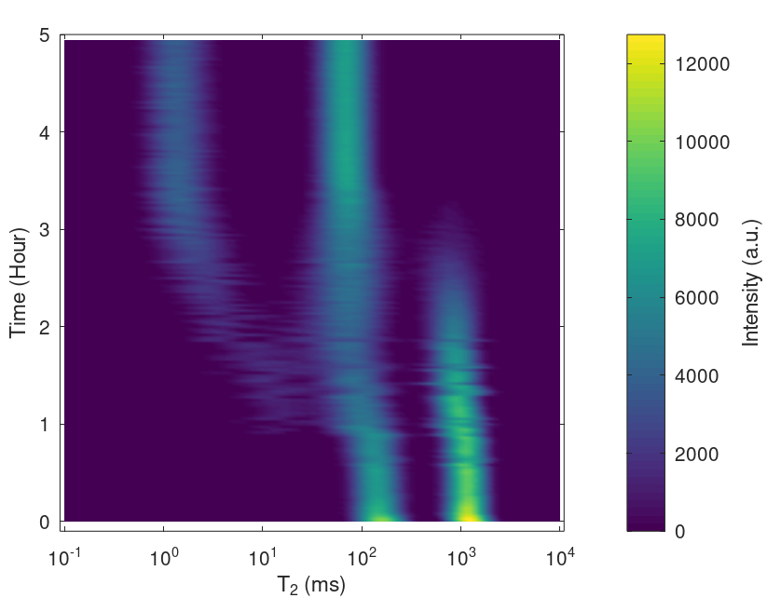

Figure S6: Loading of Marathon MSC resin with Ni²⁺ ions. T₂ distribution obtained by the Inverse Laplace Transform of the CPMG relaxation curves. m_{resin} = 12.3 g, flow rate = 4.3 ml/min.

Figure S7: curve of return to equilibrium of transverse magnetization for the bottom of the column bed after (t = 4.94 h) the complete loading of IR120 resin with Cu²⁺ ions.

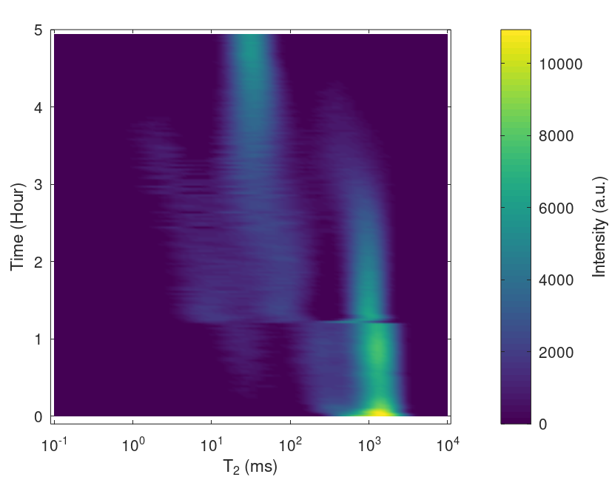
Figure S8: Loading of IR120 resin with Cu²⁺ ions. T₂ distribution obtained by the Inverse Laplace Transform of the CPMG relaxation curves. m_{resin} = 14 g, flow rate = 4.3 ml/min.

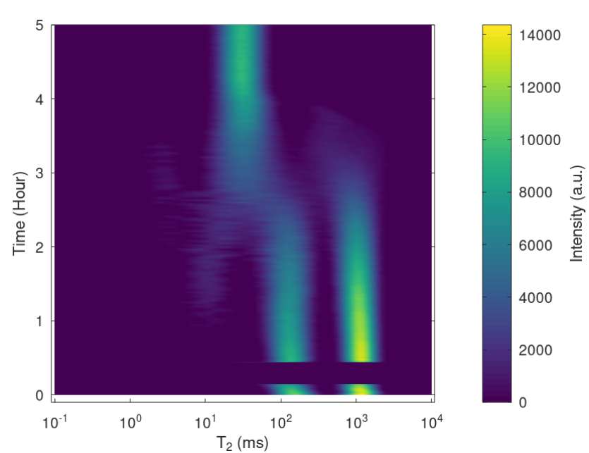
Figure S9: Loading of Marathon MSC resin with Cu²⁺ ions. T₂ distribution obtained by the Inverse Laplace Transform of the CPMG relaxation curves. m_{resin} = 12.3 g, flow rate = 4.3 ml/min.

