Investigating the effect of ultrasonication on the activation step of electroless copper of polymeric materials using Cu₂O as the catalyst

Seyed Mohamad Javad Sajjadi Shourije^{1,2}, Veronique Vitry², Golnaz Taghavi Pourian Azar¹, Thais Tasso Guaraldo¹, Andrew J Cobley¹

¹ Functional Materials and Chemistry Group, Coventry University, Coventry, United Kingdom
² Metallurgy Department, University of Mons, 7000 Mons, Belgium

Electroless deposition on to substrates such as polymers and textiles require a critical activation step in which the substrate is activated by using a catalyst. Palladium is widely used as the catalyst for electroless deposition of such substrates but it is a very expensive element, a critical raw material and is also hazardous for the environment. Thus, in this work, the potential usage of Cu₂O nano particles as a novel catalyst for electroless copper plating on polyester textile substrates was investigated as a replacement for palladium. First, the electrocatalytic performance of Cu₂O nano particles toward the oxidation of formaldehyde was investigated. In the next step, Cu₂O nano particles were used in order to activate a polyester textile for metallisation via an electroless copper process. The effects of the type of dispersion of the Cu₂O nano particles including magnetic stirrer agitation as well as sonication (300 W power and 40 kHz frequency) during the activation step was investigated with regard to final properties of copper deposits including resistivity of the coating and surface coverage were determined. The results showed that Cu₂O can successfully initiate the electroless copper process on the textile and produced a uniform copper deposition on the fibres within the textile. In addition, it was found that the dispersion method of Cu₂O nano particles plays a significant role in the quality of the final copper deposits. In particular, the results showed that the resistivity values for the electroless coatings were decreased significantly by using sonication during the activation step and produced values that were very similar to those found when the textile was activated by the palladium catalyst. This indicated that using sonication not only leads to surface coverage improvement but it can act as a surface treatment process at the same time during the activation step which can improve the adhesion and conductivity of the final coating.
Keywords: Electroless copper, Ultrasound, Activation step
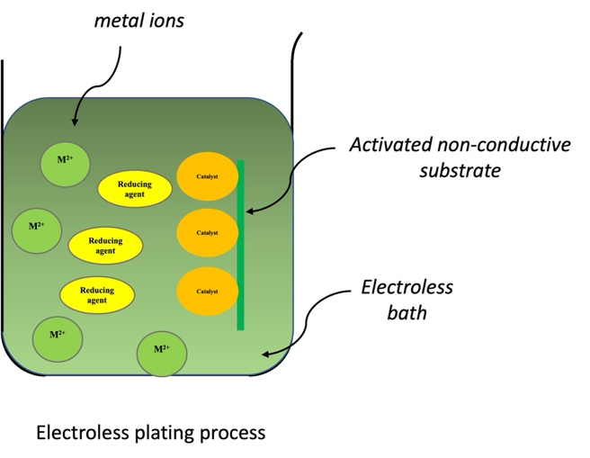
Figure 1. Schematic illustration of electroless plating process of non-conductuive materials and emphasising on the importance of using a catalyst to initiate the electroless process of non-conductive materials.

