Ni-B-based Polyalloy Electrocatalyst Coatings Deposited by MSPVD for Efficient Oxygen Evolution Reaction
Kubilay Sahin*^{1,2}, Golnaz Taghavi Pourian Azar¹, John Graves ¹, Véronique Vitry², Andrew Cobley¹‬‬‬‬‬‬
¹Institute for Clean Growth and Future Mobility, Coventry University, Priory St, Coventry, CV1 5FB, UK.
²Department of Metallurgy, University of Mons (UMONS), 23 Place du Parc, B-7000 Mons, Belgium.
ahink@uni.coventry.ac.uk
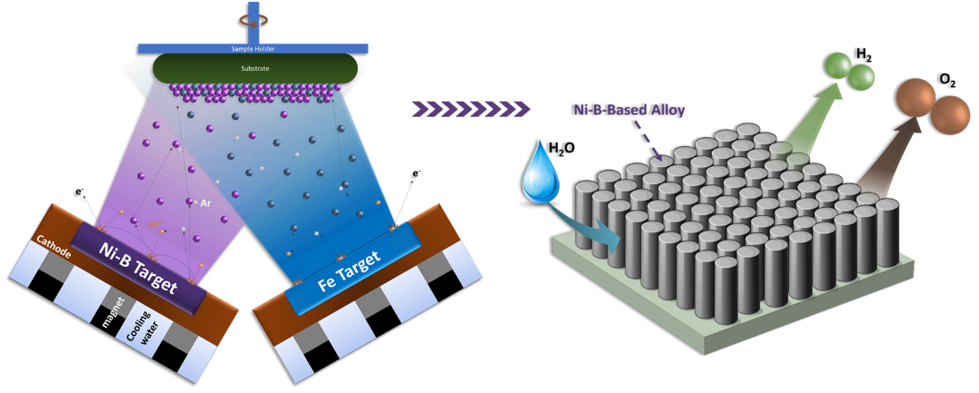
Molecular hydrogen has been considered as one of the best green energy sources due to its high energy density ¹. Water splitting is a highly promising approach to generate molecular hydrogen without any damage to environmental health. However, electrocatalyst materials, which are generally expensive noble elements, are required to complete the reactions efficiently and sustainably. Due to their excellent features such as low cost, high abundance, high corrosion resistance and durability, catalytic activity, and good synergistic effect with other elements, Nickel-based electrocatalysts have been reported as one of the most valuable alternatives to expensive noble metals ². Electrodeposition, electroless plating, hydrothermal deposition, and physical vapour deposition are some of the used techniques to synthesize Nickel-based electrocatalysts. Electroless nickel-boron plating is a remarkably beneficial technique to produce Ni-B coatings with outstanding features such as hardness, wear resistance, and corrosion resistance. In recent studies, Ni-B coatings have also demonstrated encouraging catalytic activity with remarkable stability ³. While Ni-B coatings have been extensively studied for various applications, there is not enough research on their catalytic applications. Furthermore, there is no existing literature regarding the deposition of Ni-B coatings utilising a technique other than electrodeposition or electroless plating. However, the Magnetron Sputtering Physical Vapour Deposition (MSPVD) technique has the capability of producing Ni-B coatings with porous and tunable structures together with easy alloyability to further improve the electrochemical performance.
The current study is designed to investigate the electrocatalytic performance of Ni-B-based polyalloy coatings produced by MSPVD. Polyalloy coatings were co-deposited using a Ni-B and transition metal targets such as Fe, Co, and Mo. The coatings were deposited at different deposition parameters such as chamber pressure, substrate type and different chemical compositions. The electrocatalytic performance of the coatings was compared to see the effect of boron, alloying elements, morphology and crystal structure for the Oxygen Evolution Reaction. Superior features like low overpotentials, high stabilities, and high surface areas were obtained after the electrochemical analyses such as Linear sweep voltammetry, cyclic voltammetry, chronoamperometry and electrochemical impedance spectroscopy under alkaline conditions. The results showed promising efficiencies and stabilities for highly tunable, cost-effective Ni-B-based electrocatalyst coatings.
1 D. G. Nocera, Chemistry of personalized solar energy, Inorg. Chem., 2009, 48, 10001–10017.
2 V. Vij, S. Sultan, A. M. Harzandi, A. Meena, J. N. Tiwari, W. G. Lee, T. Yoon and K. S. Kim, Nickel-based electrocatalysts for energy-related applications: Oxygen reduction, oxygen evolution, and hydrogen evolution reactions, ACS Catal., 2017, 7, 7196–7225.
3 V. Vitry, J. Hastir, A. Mégret, S. Yazdani, M. Yunacti and L. Bonin, Recent advances in electroless nickel‑boron coatings, Surf. Coatings Technol., DOI:10.1016/j.surfcoat.2021.127937.

