Correlation between lithostratigraphy and karstic speleothems at the cave of Han-sur-Lesse (Rochefort, Belgium)
Bastien Paternostre de la Mairieu, Sara Vandycke, Serge Delaby & Sophie Verheyden
The objective of this study is to investigate the correlation between speleothems (secondary carbonate deposits in caves) and rocks in which they were formed in the cave of Han-sur-Lesse in Belgium. To answer this problematic, a lithostratigraphic study of the Givetian host rock in which the speleothems were set up was based mainly on the studies of (Bultynck et al, 1991 and Coen & Coen Aubert, 1971). The study showed that the geological Formations present in the cave (Touristic network and “Réseau Sud”) are essentially those of Mont d’Haurs and Fromelennes (composed by Moulin Boreux and Flohimont Members in this cave). This study precisely locate the limits of Flohimont Member in the Artificial tunnel (Touristic network) and locate it entirely in the “Salle de la Pentecôte” (“Réseau Sud”).
In addition, the “Réseau Sud” lithostratigraphic study and more particularly of the “Salle de la Pentecôte” reveals the presence of normal and reverse faults, unexpected at this place. Theses faults are the witnesses of tectonic Hercynian and post-Hercynian events.
With all these observations, a geological map has been drawn at the altitudinal level of the galleries of the Han-sur-Lesse cave, which shows slight differences with the surface geological map and better takes into account the observations at the cave level. This map proposes that the Salle de la Pentecôte and the Salle du Corail were formed following the Flohimont Member of which part was off-set along a fault plane, most probably during Hercynian and/or post-Hercynian events.
In a second time, Laser Induced Breakdown spectroscopy (LIBS) and Raman spectroscopy, investigation have been made to understand if speleothems of the Salle de la Pentecôte can be geochemically associated with the geological formation in which they formed. Raman spectroscopy showed that aragonite speleothems (puffy matt white) and calcite speleothems (translucent white) are both present in the Salle de la Pentecôte but at different places.
LIBS on speleothems and associated rocks, showed that rocks are mainly composed by Ca, Mg, Al, Fe, Si, C (Fig. 1) with the possible presence of Sr and Ti and this composition appears directly reflected in speleothems that are associated with these rocks. This phenomenon is especially visible for Ca, Mg, Al, and C (Fig. 2). Moreover, for speleothems analysis it can be considered that they are composed by 100% of CaCO₃. Thus, C and Ca peaks were considered as internal standards. Normalization of spectra was done based on the Carbon peak, perfectly pointed at 247.9nm in contrast to calcium peaks which are numerous and whose most representative peaks can be saturated. Therefore, for speleothems, relative amounts of Mg and Al can be determined. Indeed, speleothems LIBS investigations showed that aragonite contains more Al than calcite (Fig. 2) and that the wavelength peak of 285, 3 nm characterizing Mg is more important for aragonite than calcite (Fig. 2). However up to now, with LIBS method, no relevant distinction could be made between the different limestone formations in the “Salle de la Pentecôte”.
Finally, geochemical results of the Salle de la Pentecôte has been combined with the geological map made in this master thesis and clearly shows that aragonite speleothems were formed exclusively in the Flohimont Member of the Fromelenne Formation. In opposition, calcite speleothems are present in the Mont d’Haurs Formation and Moulin Boreux Member of the Fromelennes Formation.
Therefore, it can be conclude that the investigation based on a lithostratigraphic approach combined with specific geochemical analyses of karstic rocks and speleothems, show that a clear geochemical and mineralogical link is present between the host rock and the speleothem formed within. Nevertheless, this should be further confronted with a similar approach to other contexts to be definitively conclude.
References:
Bultynck, Pierre, Marie Coen-Aubert, Léon Dejonghe, J Godefroid, L Hance, G Lacroix, Alain Preat, et al. 1991. « Les formations du Dévonien moyen de la Belgique ». Service géologique de Belgique, 30, p1-106.
Coen, M, et Marie Coen-Aubert. 1971. « L’assise de Fromelennes aux bords Sud et Est du Bassin de Dinant et dans le massif de la Vesdre. » Annales de la Societe Geologique de Belgique, 94, p5-20.
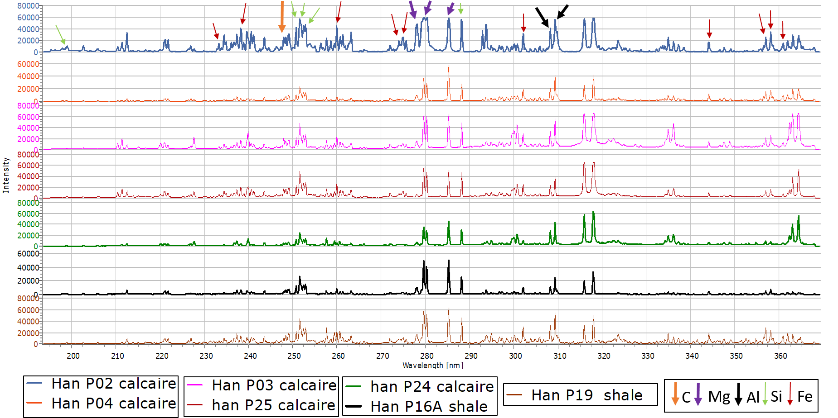
Figure 1 : Highlighting of the presence of Mg, Al, C, Si and Fe in samples rocks of "Salle de la Pentecôte" in the cave of Han-sur-Lesse by LIBS method.

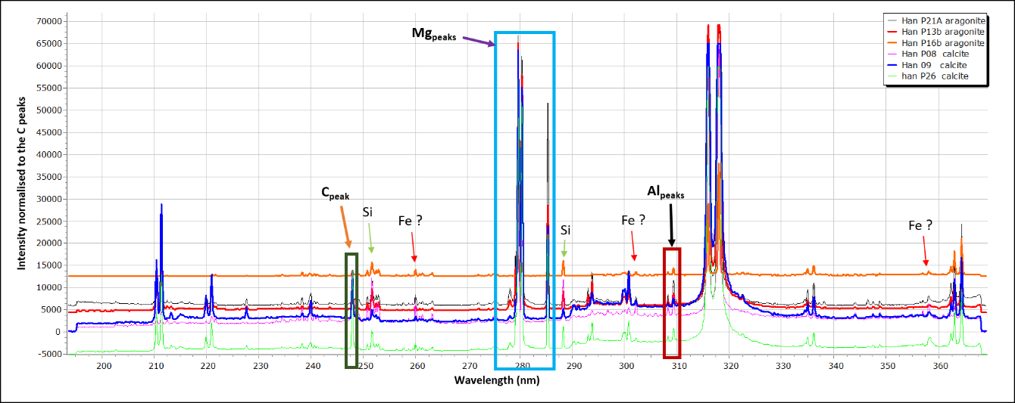
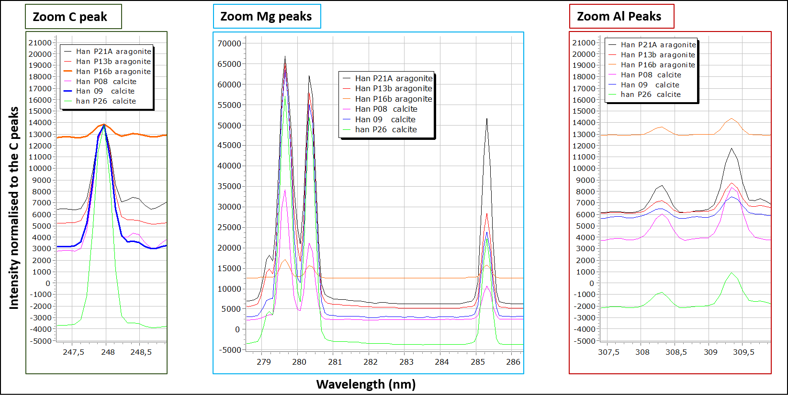
Figure 2: Speleothems samples LIBS study of "Salle de la Pentecôte" in the cave of Han-sur-Lesse. Those spectra show the presence of Mg, Al, C and Si in the all samples with possible traces of Fe. Those spectra are normalised to the C peak.

