Supplementary information

Consolidation behavior of HA-PLA nanocomposites during cold sintering process: Influence of HA-to-PLA ratio and the plasticizing effect of PLA

Muthusundar Kumar^{1,2*}, Mohamed Aymen Ben Achour², Vedi Ölmez³, Marie Lasgorceix², Rosica Mincheva¹, Anne Leriche² and Jean-Marie Raquez^{1*}

- Laboratory of Polymeric and Composite Materials, Centre of Innovation and Research in Materials and Polymers, University of Mons, Place du Parc 23, 7000 Mons, BELGIUM.
- Université Polytechnique Hauts-de-France, INSA Hauts-de-France, CERAMATHS-DMP, F-59313, Valenciennes, FRANCE.
- Belgian Ceramic Research Center, Avenue Gouverneur Cornez 4, Mons 7000, Belgium.

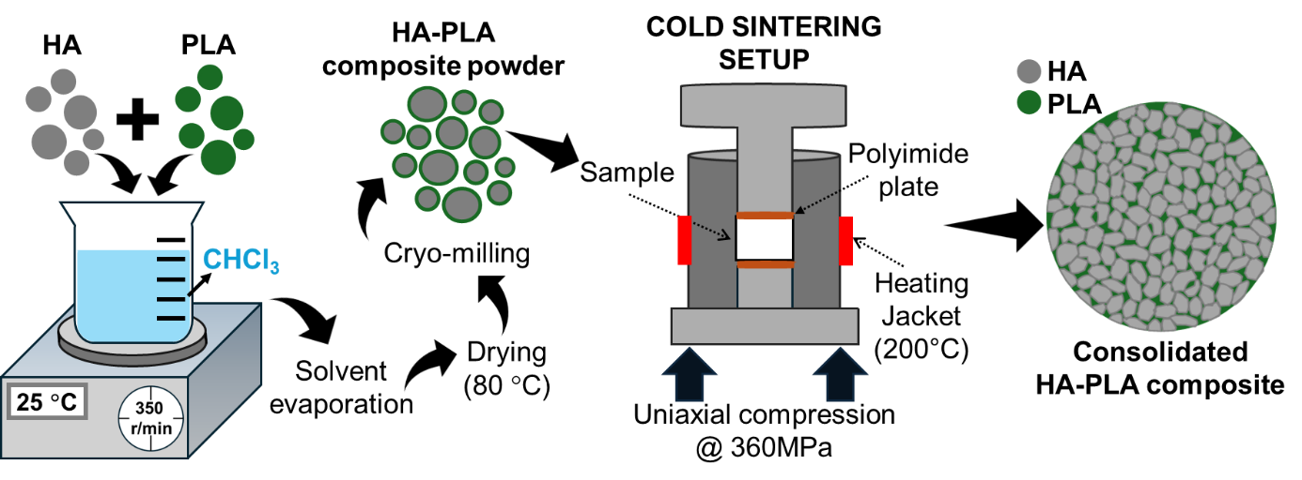
Fig. S1. Schematic illustration of the composite powder preparation and its consolidation using the cold sintering setup

Fig. S2. SEM images of Hap202 powder (a1&a2) [1], composite powder (b) HA:PLA 80:20 and (c) HA:PLA 70:30.
The HA powder consists of spherical aggregates of nano-sized HA particles, as reported before [1]. In Fig. S1, the HA:PLA 80:20 composite powder retains these spherical aggregates, with PLA adsorbed on the surface of the HA particles. This surface adsorption of PLA explains why the composite powder maintains a free-flowing, soft texture after the evaporation of chloroform. However, as the PLA content increases, the PLA-encapsulated HA aggregates begin to bind together, forming hard lumps once the chloroform solvent evaporates. Fig. S1 further illustrates that the HA:PLA 70:30 composite powder exhibits irregular particle morphology, with varying sizes within the sub-micron range after cryo-milling, indicating that higher PLA content disrupts the uniformity of powder texture.
Fig. S3 (left) The measured volume shrinkage profile for the HA powders cold-sintered without liquids under a pressure of 360 MPa, with the inset dotted lines representing the heating program during the CSP. (Right) SEM micrograph of the fractured surface, captured at 150Kx, of the cold-sintered HA powder without liquid [1].
Fig. S4 FIB cross-sectioned SEM micrographs of 80:20 (a₁ & a₂) captured at a magnification of 3Kx and 100Kx, and 70:30 fraction (b₁ & b₂) captured at a magnification of 5Kx and 50Kx.
Fig. S5. Illustration of the Soxhlet extraction setup and the HA matrix extracted after PLA extraction.
Table S1. DSC parameters of PLA and TBC plasticized PLA

Sample | T_{g} | T_{c} | T_{m}
PLA6201D | 62.3 | 143.4 | 169.2
5TBC/PLA | 52.7 | 100.4 | 168.3
10TBC/PLA | 39.6 | 90.2 | 165.7
20TBC/PLA | 27.4 | 77.9 | 163.6

Fig. S6. (a) DSC thermogram, (b) XRD patterns, and (c and d) FTIR plot of the HA:PLA composite made with unplasticized PLA.
As illustrated in Fig. 2(b₁ to d₁), increased PLA content restricts HA aggregates' de-aggregation and HA consolidation in the composite matrix. In the composite samples HA:PLA 50:50 and 60:40, the observation of dual melting peaks at 153 and 160 °C can be attributed to the differing interaction between the different crystalline regions of PLA and HA within the composite [2, 3]. In contrast, the composite HA:PLA 70:30 has a very broad melting peak. The variations in melting peaks concerning PLA content may result from differences in the dense packing of HA aggregates (Fig. 2(b₁ to d₁)). This packing might influence the crystallization of PLA, as the nucleation effect of HA lowers with a reduction in its content. However, no significant differences were observed as PLA content increased, except for the increasing intensity of the diffraction peak at 2θ = 16.6°, which corresponds to the (110)/(200) lattice planes of PLA. Additionally, these composite holds hydrogen bonding between HA and PLA as evidenced by the red-shift of the characteristic vibration peak for PLA6201D at 1748 cm⁻¹, corresponding to C=O stretching vibration [4].

References
- M. Kumar, M.A.B. Achour, M. Lasgorceix, P. Quadros, R. Mincheva, J.M. Raquez, and A. Leriche, Densification of hydroxyapatite through cold sintering process: Role of liquid phase chemistry and physical characteristic of HA powder. Open Ceram., 17 (2024) 100566. https://doi.org/10.1016/j.oceram.2024.100566
- T. Tábi, S. Hajba, and J.G. Kovács, Effect of crystalline forms (α′ and α) of poly (lactic acid) on its mechanical, thermo-mechanical, heat deflection temperature and creep properties. Eur. Polym. J., 82 (2016) 232-243. https://doi.org/10.1016/j.eurpolymj.2016.07.024
- C.A. Gracia-Fernández, S. Gómez-Barreiro, J. López-Beceiro, S. Naya, and R. Artiaga, New approach to the double melting peak of poly (l-lactic acid) observed by DSC. J. Mater. Res., 27 (2012) 1379-1382. https://doi.org/10.1557/jmr.2012.57
- S. Zhou, X. Zheng, X. Yu, J. Wang, J. Weng, X. Li, B. Feng, and M. Yin, Hydrogen bonding interaction of poly (D, L-lactide)/hydroxyapatite nanocomposites. Chem. Mat., 19 (2007) 247-253. https://doi.org/10.1021/cm0619398

