Title: GenZ versus GenAI: A Cross-Sectional Study Assessing Medical Students’ Confidence and Overreliance in Perioperative Clinical Scenarios
Short Title: Gen Z Vs Gen AI
Authors: Sarah Saxena¹, Marc Nkana Tsobgnie¹, Roberta Südy², Mia Gisselbaek², Jerome Lechien¹, Michele Carella³, Pierre Luigi Ingrassia⁴, Peter Dieckmann ⁵, Joana Berger-Estilita⁶
Affiliations:
- Department of Surgery, UMons, Research Institute for Health Sciences and Technology, University of Mons, Mons, Belgium
- Division of Anesthesiology, Department of Anesthesiology, Clinical Pharmacology, Intensive Care and Emergency Medicine, Geneva University Hospitals and Faculty of Medicine, Geneva, Switzerland.
- Department of Anesthesia and Intensive Care Medicine, Liege University Hospital, Liege, Belgium
- Centro di Simulazione (CeSi), Centro Professionale Sociosanitario Medico-Tecnico, Lugano, Switzerland.
- Copenhagen Academy for Medical Education and Simulation (CAMES), Capital Region of Denmark, Herlev, Denmark
- Institute for Medical Education, University of Bern, Bern, Switzerland.
Corresponding Author: Sarah Saxena (sarah.saxena@ulb.be)
Article type: Short Scientific Report
Word Count 1141
Figure 1
Supplement 1

Editor,
Generation Z, individuals born between 1996 and 2010, represents the first generation to have grown up immersed in advanced technology, including the ability to immediately communicate and learn through a wide range of digital platforms and applications. (1) Now entering medical education and clinical practice, Gen Z comprises today’s medical students and early-career clinicians. Their educational experiences have been shaped by immediate access to information through online learning tools.
Recently, medical students have started using Generative Artificial Intelligence (GenAI), a subset of AI capable of generating text and synthesizing knowledge, to compliment their textbooks for clinical decision-making. (2)
While studies have highlighted the potential advantages of Large language models (LLMs), there is limited evidence evaluating how these tools perform when applied to real-world clinical scenarios and more importantly, which datasets these tools rely on. (3)
Understanding how GenAI models compare to human learners in solving clinical problems, and how confident medical students are in AI versus their own reasoning, is essential for developing balanced, evidence-based approaches to integrating AI into medical education.
The primary aim of this cross-sectional, web-based, comparative design study was to evaluate the performance and reliability of common Generative AI models (ChatGPT, Gemini, and Claude) in solving perioperative clinical scenarios when compared to the responses of 30 fourth-year medical students. Specifically, we aimed to compare the accuracy and quality of AI-generated solutions with those provided by medical students, assess the degree of agreement between AI-generated responses and expert-defined criteria and lastly, explore how confident students are in their own answers versus those generated by AI.

This study followed the World Medical Association Declaration of Helsinki Ethical Principles for Medical Research Involving Human Subjects. Consent to participate was obtained from all participants. Ethical approval was waived (Cantonal Ethics Committee of Bern (KEK Bern): BASEC-number: Req-2025-00242). Reporting followed the Strengthening the Reporting of Observational Studies in Epidemiology (STROBE) guidelines.
This study was conducted at the University of Mons, Belgium on February 28, 2025. After having attended anesthesiology classes during the month of February, 30 fourth year medical students were presented with a survey collecting their demographic data, their perception of familiarity with Generative AI, their management of two clinical perioperative scenarios. These scenarios were developed by two domain experts (MC, PLI) who predefined four essential keywords required in the response. (Appendix 1)
Each participant was given 30 minutes to submit their response. Afterwards, the same scenarios were entered into three Generative AI models: ChatGPT-4 (OpenAI), Gemini (Alphabet Inc.), and Claude (Anthropic). A total of 3×30 AI-generated responses were gathered.
To maintain anonymity, all responses—both from students and AI models—were stored, anonymized, labeled and blinded on Google Documents by a researcher (MNT) not involved in the data analysis. Another researcher (SS) independently reviewed and scored the responses based on the presence of the four predefined keywords, with each response receiving a score from 0 to 4. The scoring data was then recorded, unblinded and subsequently analysed by a statistician (RS).
Normal distribution of the data was tested by Shapiro-Wilk test. Data are reported as median and interquartiles ranges. To assess the proportion of predefined keywords correctly included in responses, Kruskall-Wallis test was performed with post hoc Bonnferroni-Dunn comparison. The mean keyword inclusion scores between medical students and LLM-generated responses was characterised by Linear Mixed-Effects Models with Tukey post hoc analysis. Residual diagnostics confirmed model fit, with normally distributed residuals centered around zero. Spearman correlation test was used to characterized the relationship between perceived and actual AI. All reported p values are two-sided with a level of significance of p<0.05. All statistical analyses were carried out using Python, including statsmodels for linear mixed-effects modeling, scikit_posthocs for non-parametric post hoc comparisons, and matplotlib/seaborn for visualization.
The median age of the medical students was 22 (21,23), with 60% identifying as female (18/30). 80% (24/30) of medical students use GenAI tools, with 37% (11/30) reporting a daily use and 20% (6/30) occasional use. 20% (60/30) never use GenAI tools. 47% (14/30) rated GenAI as having a moderate impact on their studies, while in 27% (8/30) students this went up to a major impact. (Supplement: Table 1)
Regarding both perioperative scenarios, all AI models significantly outperformed the medical students (p < 0.001), with small but significant differences between Gemini and ChatGPT (p = 0.0444). Regarding the average scores of the two scenarios, all three GenAI tools significantly outperformed students (p < 0.001), with no statistically significant differences among the AI tools themselves (all p > 0.05). (Supplement: Figure 1)
Comparing the average scores within the two scenarios, we found significant differences in scores of students (p<0.001) and all AI models between the two scenarios (p<0.001, p=0.0089 p=0.0044, for ChatGPT, Gemini, Calude, respectively). Significant differences were observed between each AI model and students both in scenario 1 and scenario 2 (p<0.001for all). (Supplement: Figure 2)
The relationship between perceived and actual AI accuracy is shown in Figure 1. There is a moderate, but significant negative correlation (r = –0.56, p = 0.0016) between the variables indicating that students tended to overestimate AI accuracy.
This study highlights a critical issue in medical education: while Generative AI tools like ChatGPT, Gemini, and Claude significantly outperformed fourth-year medical students in solving complex perioperative clinical scenarios, students exhibited high confidence in these tools—often without a clear understanding of their limitations. Notably, there was a moderate but significant negative correlation between perceived and actual AI accuracy. Students who believed most strongly in the accuracy of AI were, paradoxically, the least accurate in their ability to assess its responses.
This finding suggests a growing overreliance on AI, driven not by informed judgment, but by perceived convenience and authority of technology. Such blind trust in AI systems, without proper training in their appropriate use, risks not only reducing the development of sound critical clinical reasoning but also reinforcing cognitive distortions like impostor syndrome, already prevalent in early medical careers. (4 ; 5)
Rather than AI being used as a complimentary tool for reflection and learning, students may be outsourcing complex thinking without engaging deeply with the material themselves. This trend highlights a fundamental tension: while AI can streamline knowledge retrieval and expose learners to diverse perspectives, it must not become a crutch that substitutes active learning or diagnostic intuition.
Medical education must urgently integrate critical AI literacy into its curricula. Students need training not just on how to use GenAI tools, but on when not to rely on them—understand their sources and limitations, and recognize when human judgment must take precedence. (6)
In conclusion, while Generative AI holds immense potential to complement medical education, our findings suggest that student confidence in AI is often misplaced and may be contributing to an overdependence on these technologies.
Ensuring that future physicians are empowered to use AI critically, rather than deferentially, is not just an educational priority—it is a patient safety imperative.

Figure legend

Figure 1: Relationship Between Perceived and Actual AI Accuracy
Scatter plot showing the relationship between medical students’ perceived accuracy of generative AI responses and the actual performance of AI models based as the average normalized keyword match score across three AI models (ChatGPT, Gemini, and Claude). Each dot represents an individual student. Jitter was added to reduce overlap. The fitted linear regression line (blue) shows the general trend with the 95% confidence interval for the regression line.

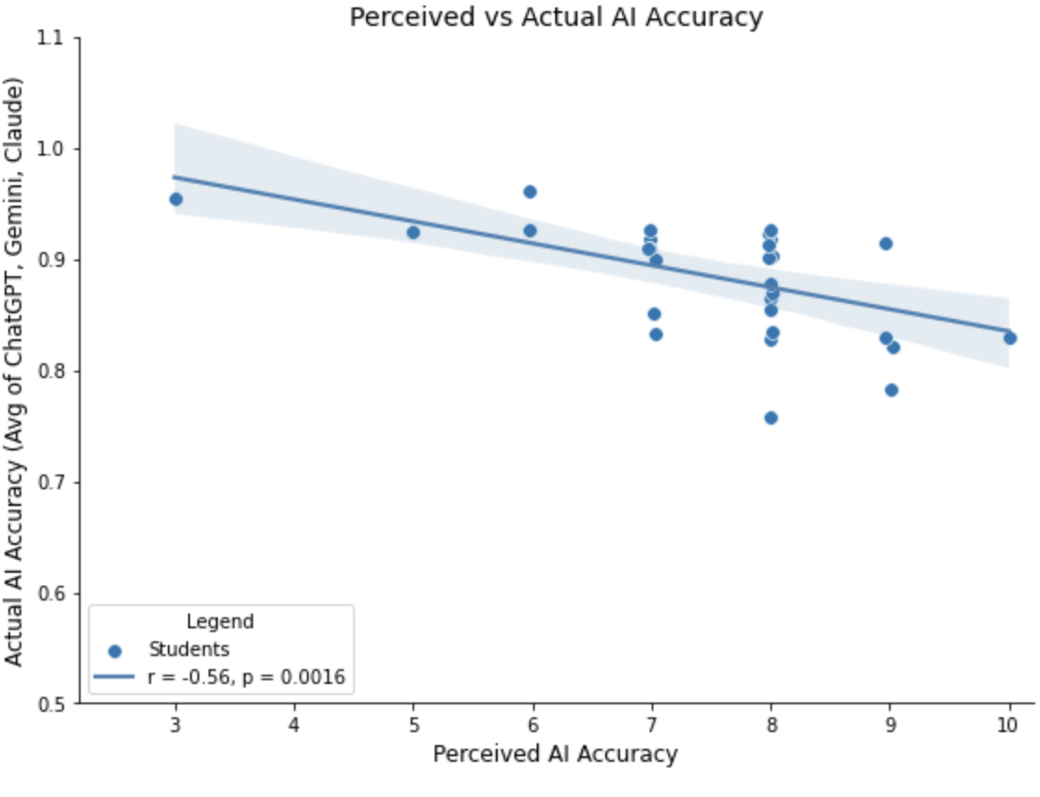

References (max 7)
- Lerchenfeldt S, Attardi SM, Pratt RL, Sawarynski KE, Taylor TAH. Twelve tips for interfacing with the new generation of medical students: iGen. Med Teach 2021; 43(11):1249-1254. doi: 10.1080/0142159X.2020.1845305. (PMID: 33174808)
- Arango-Ibanez JP, Posso-Nuñez JA, Díaz-Solórzano JP, Cruz-Suárez G. Evidence-Based Learning Strategies in Medicine Using AI. JMIR Med Educ 2024; 10: e54507. Doi : 10.2196/54507. (PMID : 38801706)
- Saxena S, Berreto Chang O, Suppan M, Ceyda Meco B, Vacas S, Radtke F et al. A comparison of large language model-generated and published perioperative neurocognitive disorder recommendations: a cross-sectional web-based analysis. Br J Anaesth 2025 ; doi: 10.1016/j.bja.2025.01.001. (PMID: 39922789)
- Siddiqui MF, Azaroual M. Combatting Burnout Culture and Imposter Syndrome in Medical Students and Healthcare Professionals: A Future Perspective. J Med Educ Curric Dev 2024; 11: 23821205241285601. doi: 10.1177/23821205241285601 (PMID: 39371645)
- Gisselbaek M, Hontoir S,Pesonen AE, Seidel A, Geniets B, Steen E et al. Impostor syndrome primarily affects female and junior physicians. Br J Anaesth 2024 ; 132 (2) : 407- 409. DOI: 10.1016/j.bja.2023.09.025 (PMID: 37884406)

- Gisselbaek M, Berger-Estilita J, Devos A, Ingrassia PL, Dieckmann P, Saxena S. Bridging the Gap Between Scientists and Clinicians: Addressing Collaboration Challenges in Clinical AI Integration. BMC Anesth 2025 Accepted for publication

