Supplementary material for Polymetallic interactions of Zn-Pb-Cu in blue/green-colored speleothems from Malaval Cave (France)
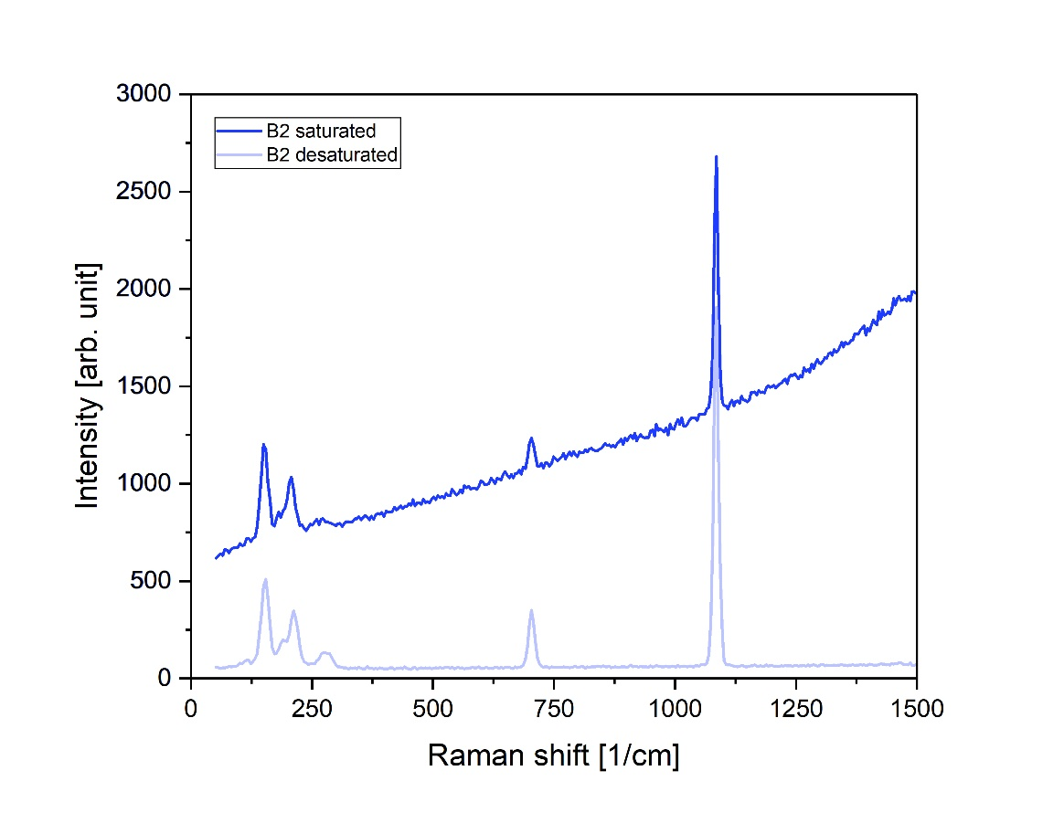
Supplementary data figure 1. Raman spectra from the saturated and desaturated blue zones of sample B2.
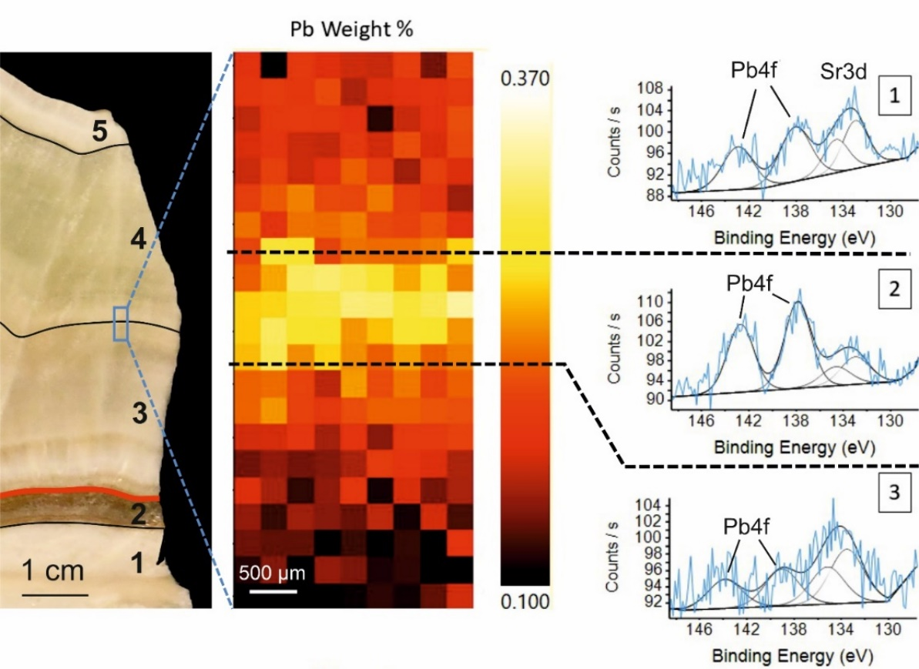
Supplementary data figure 2. XPS mapping of the transition between zones 3 and 4 of sample STAL (blue rectangle on the left-hand picture), focused on Pb concentration. Graphs show the intensity of Pb4f XPS peaks varying strongly between the zones.
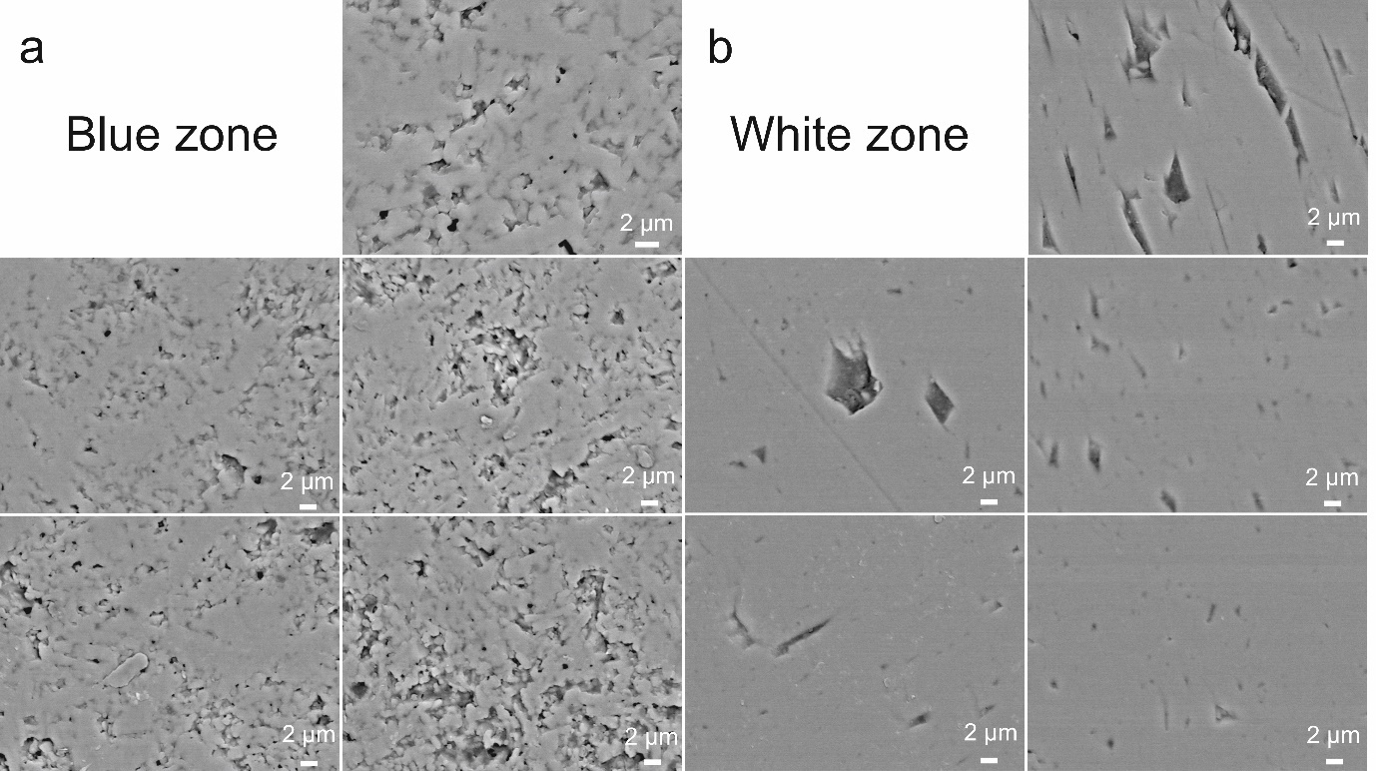
Supplementary data figure 3. Close-up secondary electrons views of blue (a) and white (b) zones from the blue aragonite sample B2. The blue zone (Pb-rich) shows a very porous and uneven mineral structure, while the uncolored zone (Pb-depleted) is much smoother and more homogeneous.
Supplementary data table 1. EDS analyses performed on high Z spots within blue aragonite samples from Malaval Cave, sorted from lowest to highest Zn content. ND = not detected.
Sample | O (wt%) | Ca (wt%) | Cu (wt%) | Zn (wt%) | Si (wt%)
B4 | 50.5 | 40.6 | ND | 6.7 | 2.0
B3 | 44.3 | 40.8 | 5.4 | 9.4 | ND
B3 | 40.4 | 35.2 | 8.2 | 16.2 | ND
B4 | 39.5 | 33.7 | ND | 20.8 | 6.0
B3 | 36.9 | 22.5 | 15.8 | 24.8 | ND
B4 | 37.7 | 28.9 | 5.1 | 26.9 | 1.4
B4 | 40.7 | 21.4 | 6.0 | 30.1 | 1.8
B4 | 38.9 | 20.1 | 7.3 | 32.7 | 0.9
B3 | 30.6 | 16.0 | 19.7 | 33.1 | 0.5
B4 | 37.3 | 18.7 | 6.2 | 36.1 | 1.6
B4 | 35.6 | 17.6 | 6.1 | 37.9 | 2.8
B3 | 33.9 | 12.8 | 12.9 | 39.6 | 0.8
B3 | 26.8 | 12.6 | 9.6 | 44.3 | 6.6
B4 | 25.8 | 18.0 | 8.2 | 45.0 | 2.9
B4 | 26.8 | 20.6 | 5.3 | 45.8 | 1.5
B4 | 33.9 | 9.8 | 6.1 | 48.5 | 1.8
B4 | 27.1 | 16.4 | 5.2 | 49.6 | 1.7
B3 | 27.4 | 5.6 | 5.3 | 51.3 | 10.3
B4 | 25.8 | 8.9 | 7.2 | 51.8 | 6.2
B4 | 19.7 | 11.5 | 9.4 | 55.5 | 3.8
B4 | 27.9 | 6.3 | 6.4 | 56.7 | 2.7
B3 | 23.2 | 4.9 | ND | 59.5 | 12.3
B4 | 27.3 | 2.5 | 7.0 | 60.8 | 2.3
B4 | 24.0 | 2.7 | 6.8 | 63.9 | 2.6
Supplementary data table 2. Results for the EDS analyses performed on the undetermined Zn-bearing phases and on the aragonite of sample W1. ND = not detected.
Phase | O (wt%) | Ca (wt%) | Mg (wt%) | Zn (wt%) | Si (wt%) | C (wt%)
Blue phases | 39.5 | 0.4 | 1.6 | 33.5 | 4.0 | 21.1
Blue phases | 37.6 | 0.6 | 2.3 | 36.0 | 5.5 | 18.3
Blue phases | 38.6 | 1.9 | 2.2 | 32.6 | 5.1 | 19.6
Blue phases | 34.5 | 0.3 | 2.6 | 39.5 | 5.9 | 17.0
Blue phases | 30.9 | 0.7 | 1.5 | 35.5 | 3.6 | 27.7
Blue phases | 32.2 | 0.9 | 1.5 | 47.9 | 3.0 | 14.5
Aragonite | 47.0 | 37.4 | ND | ND | ND | 16.5
Aragonite | 46.7 | 38.0 | ND | ND | ND | 15.3
Aragonite | 50.8 | 36.2 | ND | ND | ND | 12.9

Supplementary data table 3. ICP-MS results for the most concentrated metals. Samples are grouped as in Figure 7.
 |  | Cu (ppm) | Zn (ppm) | Sr (ppm) | Ba (ppm) | Pb (ppm)
Host rock | HR1 | 10 | < 30 | 140 | 36 | < 5
White | W2 | 20 | 30 | 2504 | 287 | < 5
White with blue phases | W1 | 120 | 1520 | 1039 | 150 | 37
Blue | B1 | 250 | 1460 | 1735 | 136 | 31
Blue | B2 | 230 | 1940 | 1563 | 329 | 185
Blue | B3 | 230 | 1460 | 1377 | 320 | 426
Blue | B4 | 180 | 2680 | 1179 | 196 | 69

Supplementary data table 4. Determination coefficients matrix of the metal concentrations in all samples from Supp. data table 3, showing that only Zn and Cu are somewhat correlated.
R² | Cu | Zn | Sr | Ba | Pb
Cu | - | 0.608 | 0.035 | 0.162 | 0.323
Zn | 0.608 | - | 5.57E-05 | 0.074 | 0.099
Sr | 0.035 | 5.57E-05 | - | 0.460 | 0.002
Ba | 0.162 | 0.074 | 0.460 | - | 0.414024
Pb | 0.323 | 0.099 | 0.002 | 0.414 | -

Supplementary data table 5. Determination coefficients matrix of the metal concentrations in STAL (Figure 8), showing very poor correlation between metals except for Cu and Zn.
R² | Cu | Zn | Sr | Pb
Cu | - | 0.633 | 0.001 | 0.008
Zn | 0.633 | - | 0.215 | 0.007
Sr | 0.001 | 0.215 | - | 0.188
Pb | 0.008 | 0.007 | 0.188 | -

