Transposition of the Complementary Developing Solvent Technique to Flash Chromatography: A Structured Step-Based Fractionation Strategy for Complex Plant Extracts
Supplementary Material

Authors:
Jason Fauquet¹, Adam Ellatiff¹, Claudio Palmieri¹, Pierre Duez¹, Bertrand Blankert², Mathilde Wells² and Amandine Nachtergael¹
Corresponding author: Jason Fauquet, Jason.FAUQUET@umons.ac.be
Affiliation:
¹Laboratory of Therapeutic Chemistry and Pharmacognosy, Research Institute for Health Sciences and Technology, Research Institute for Bioscience, Faculty of Medicine, Pharmacy and Biomedical Sciences, University of Mons (UMONS), Belgium
²Laboratory of Pharmaceutical Analysis, Research Institute for Health Sciences and Technology, Research Institute for Bioscience, Faculty of Medicine, Pharmacy and Biomedical Sciences, University of Mons (UMONS), Belgium

Table of contents
1 Figure S1 3
2 Table S1 4
3 Table S2 5
4 Figure S2 6
5 Figure S3 7
6 Table S3 8
7 Table S4 8
8 Table S5 9
9 Table S6 9
10 Table S7 9
11 Table S8 - Feasibility assessment of MPDS transposition to normal-phase flash chromatography 10
12 Python script for HPDS: 11
12.1 Purpose and output of the script. 13
13 Python script for LPDS: 14
13.1 Purpose and output of the script. 16

Figure S1

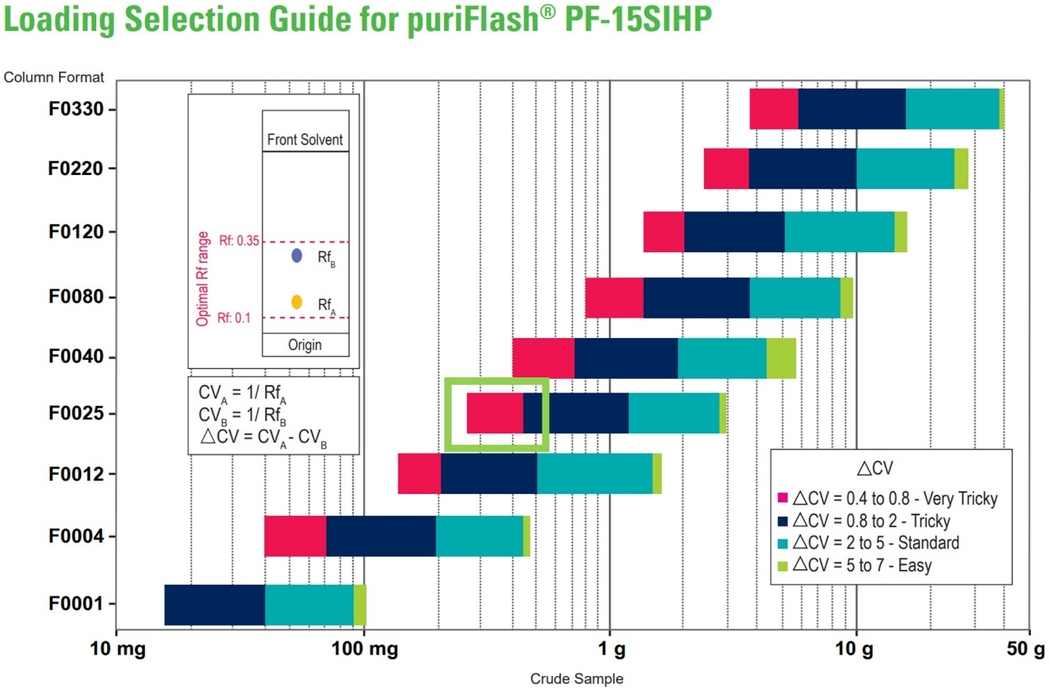
Figure S1: Loading selection guide for puriFlash PF-15SIHP columns (adapted from [1]). This figure provides a practical guide for selecting the appropriate crude sample loading mass according to the column format and the estimated separation difficulty derived from HPTLC data. The horizontal axis represents the crude sample mass loaded onto the column, while the vertical axis lists the available puriFlash® PF-15SIHP silica column formats. The separation difficulty is expressed as ΔCV, defined here as the difference in column volumes (CV) between two adjacent compounds (ΔCV = CV_A − CV_B), where CV is estimated from HPTLC retention factors using the relationship CV = 1/Rf. Smaller ΔCV values (red and dark blue zones) indicate closely spaced compounds and therefore challenging separations, whereas larger ΔCV values (cyan and green zones) correspond to better-resolved compounds and easier separations. The inset schematic illustrates the estimation of ΔCV from two neighboring HPTLC spots within the optimal Rf range. To use this guide, the user first estimates ΔCV from the HPTLC plate, then selects the corresponding color-coded difficulty zone, and finally identifies the recommended loading mass range for the chosen column format. As an example, for a 25 g silica column with a particle size of 15 µm and closely spaced HPTLC spots resulting in ΔCV = 0.4–0.8, the recommended loading mass falls within the red zone highlighted by the green frame.

Name | CAS n° | Provided by (reference) | Purity (%) | Lot/Batch
Toluene  GPR RECTAPUR® | 108-88-3 | VWR (28675.465) | ≥ 99.0 | N.A
Ethyl acetate a.r.  For laboratory use, ACS, ISO, Ph. Eur. | 141-78-6 | ChemLab (CL00.0502) | ≥ 99.5 | N.A
Méthanol AnalaR  NORMAPUR® ACS, Reag. Ph. Eur. | 67-56-1 | VWR (20847.466) | ≥ 99.8 | N.A
Dichloromethane  For analysis EMSURE® ACS,ISO,Reag. Ph Eur | 75-09-2 | Sigma-Aldrich (1.06050) | ≥ 99.8 | N.A
Ethanol absolute  Ph. Eur., USP | 64-17-5 | VWR (20816.367) | ≥ 99.5 | N.A
Tetrahydrofuran  stabilized, GPR RECTAPUR | 109-99-9 | VWR (28552.290) | ≥ 99.0 | N.A
Ultra pure water | 7732-18-5 | Purification system  (Milli-RO, Merck Millipore) | 18.5 MΩ·cm ; 25°C | N.A
Water + 0.1 % Formic acid LC-MS | 7732-18-5  (64-18-6) | VWR (84867.320) | 0.095 – 0.0105 | N.A
Methanol LC-MS | 67-56-1 | ChemLab (CL00.3915) | > 99.98 | N.A
Formic acid AnalaR  NORMAPUR® ACS, Reag. Ph. Eur. | 64-18-6 | VWR (20318.297) | ≥ 99.0 | N.A
Guanosine | 118-00-3 | Sigma-Aldrich (G6752) | 99.2 | BCCJ8525
Sulisobenzone | 4065-45-6 | Sigma-Aldrich (09649) | 98.8 | 199111
Thymidine | 50-89-5 | Sigma-Aldrich (89270) | 99.5 | BCCH6521
Paracetamol | 103-90-2 | Sigma-Aldrich (A5000) | 99.4 | MKCT8276
Phthalimide | 85-41-6 | Sigma-Aldrich (240230) | 99.7 | MKCP3478
9-fluorenol | 1689-64-1 | Sigma-Aldrich (H31204) | > 99.9 | STBK8574
Thioxanthone | 492-22-8 | VWR (APOSOR6559) | 95.0 | AS510287
Octrizole | 3147-75-9 | Sigma-Aldrich (322806) | 98.4 | MKBH2059V
Silica gel NORMASIL 60® 40-63 µm | 7631-86-9 | VWR (27623.323) | N.A | 18H164134
HPTLC silica gel 60 F254 Glass plates 20 × 10 cm | N.A | VWR (1.05642.0001) | N.A | HX30551542
puriFlash® column 25 g - 15 µm | N.A | Interchim (PF-15SIHP-F0025) | N.A | Z06L210
Pure Solid loader 15g set | N.A | Büchi (11068975) | N.A | N.A

Table S1
Table S1: Chemicals and consumable materials.
All solvents, reagents, reference standards, and chromatographic consumables employed throughout the experimental work are listed with their corresponding Chemical Abstracts Service (CAS) numbers, suppliers, catalogue references, purity grades, and batch or lot numbers when available.

Table S2
Table S2: MS/MS compound-dependent parameters
Label | Name | M.W (g/mol) | Polarity | Precursor (m/z) | DP (V) | EP (V) | CE (eV) | CXP (V)
1 | Guanosine | 283,24 | Positive | 284 | 70 | 10 | 10 | 20
2 | Sulisobenzone | 308,31 | Negative | 307 | -110 | -10 | -40 | -10
3 | Thymidine | 242,23 | Negative | 241 | -100 | -10 | -20 | -10
4 | Paracetamol | 151,16 | Positive | 152 | 80 | 10 | 20 | 20
5 | Phthalimide | 147,13 | Negative | 146 | -50 | -10 | -35 | -15
6 | 9-hydroxyfluorene | 182,22 | Positive | 182 | 70 | 10 | 45 | 20
7 | Thioxanthen-9-one | 212,27 | Positive | 213 | 120 | 10 | 50 | 20
8 | Octrizole | 323,43 | Positive | 324 | 60 | 10 | 40 | 20
Compound-dependent mass spectrometric parameters were optimized individually for each reference compound in either positive or negative electrospray ionization mode. The selected precursor ions corresponded to the protonated or deprotonated molecular species. Declustering potential (DP), entrance potential (EP), collision energy (CE), and collision cell exit potential (CXP) were adjusted to maximize precursor ion transmission and to generate informative fragmentation patterns for MS/MS experiments.

Figure S2
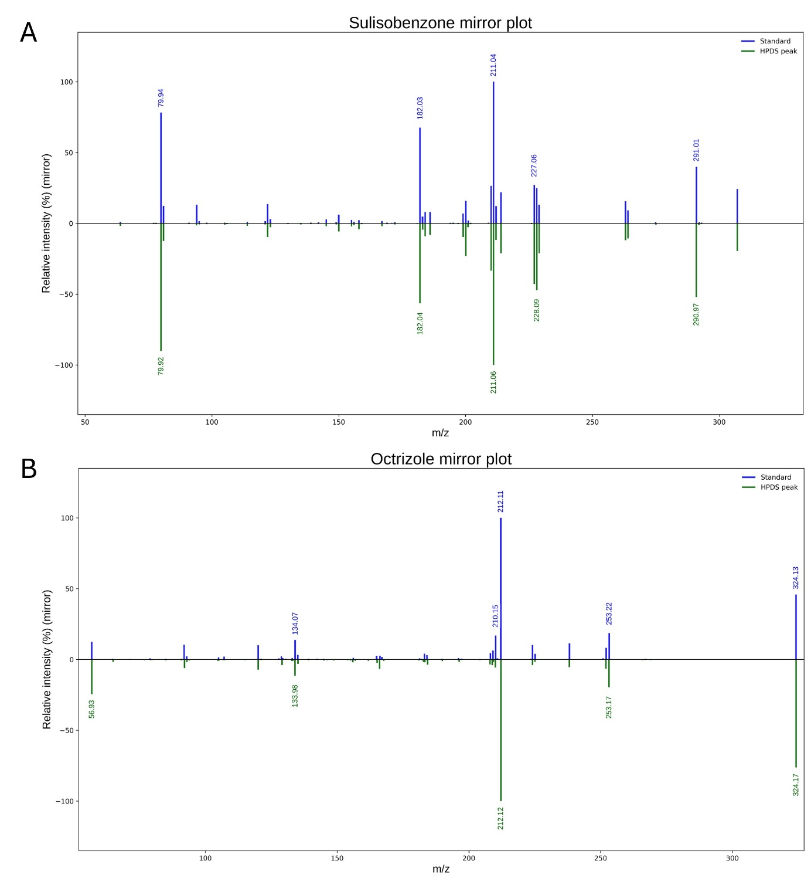
Figure S2: MS/MS structural validation for the HPDS system. Mirror plot comparison of product ion scans (MS/MS) between reference standards (top, blue) and peak fractions collected from the HPDS flash chromatography separation (bottom, green). (A) Sulisobenzone (Compound 2, [M-H]⁻ at m/z 307.0, CE = -40 eV) and (B) Octrizole (Compound 8, [M+H]⁺ at m/z 324.0, CE = 40 eV). The perfect alignment of the diagnostic fragments validates the identity of the isolated peaks and the consistency of the elution order in the HPDS system.

Figure S3
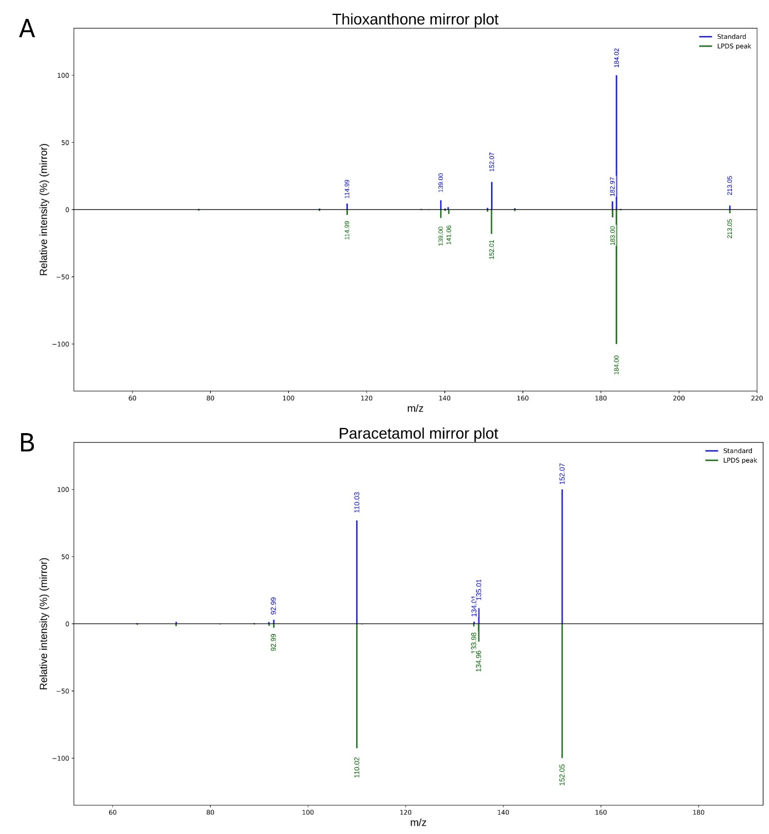
Figure S3: MS/MS structural validation for the LPDS system. Mirror plot comparison of product ion scans (MS/MS) between reference standards (top, blue) and peak fractions collected from the LPDS flash chromatography separation (bottom, green). (A) Thioxanthen-9-one (Compound 7, [M+H]⁺ at m/z 213.05, CE = 50 eV) and (B) Paracetamol (Compound 4, [M+H]⁺ at m/z 152.07, CE = 20 eV). The identical fragmentation patterns confirm the structural integrity of the analytes during the LPDS transposition.

Table S3
Table S3: Gradient of the High Polarity Developing Solvent (HPDS) system used for flash chromatography.
Time (CV) | Dichloromethane (%) | Methanol (%)
0.00 | 100 | 0
10.00 | 100 | 0
10.02 | 88 | 12
15.00 | 88 | 12
15.02 | 76 | 24
20.00 | 76 | 24
20.02 | 64 | 36
25.00 | 64 | 36
25.02 | 52 | 48
30.00 | 52 | 48
30.02 | 40 | 60
40.00 | 40 | 60
40.02 | 0 | 100
50.00 | 0 | 100
The HPDS gradient consisted of a stepwise increase in methanol in dichloromethane, expressed as CV. Each chromatographic run was preceded by an equilibration step of 3 CV with 100% dichloromethane. A final washing step at 100% methanol was applied to ensure complete elution of strongly retained polar compounds.

Table S4
Table S4: Gradient of the Low Polarity Developing Solvent (LPDS) system used for flash chromatography.
Time (CV) | Toluene (%) | Ethyl acetate (%)
0.00 | 100 | 0
10.00 | 100 | 0
10.02 | 97 | 3
15.00 | 97 | 3
15.02 | 94 | 6
20.00 | 94 | 6
20.02 | 91 | 9
25.00 | 91 | 9
25.02 | 88 | 12
30.00 | 88 | 12
30.02 | 85 | 15
40.00 | 85 | 15
40.02 | 0 | 100
50.00 | 0 | 100
The LPDS gradient consisted of a stepwise increase in ethyl acetate in toluene, expressed as CV. Each chromatographic run was preceded by an equilibration step of 3 CV with 100% toluene. A final washing step at 100% ethyl acetate was applied to ensure complete elution of retained compounds.

Table S5
Table S5: Intermediate precision of chromatographic retention (CV_{apex}) for the UHM under HPDS and LPDS conditions
Peak | HPDS – Mean CV_{apex} | SD | RSD (%) | LPDS –  Mean CV_{apex} | SD | RSD (%)
8 | 1.384 | 0.009 | 0.65 | 1.4 | 0.0 | 0.0
7 | 3.5 | 0.2 | 4.68 | 3.2 | 0.1 | 4.1
6 | 6.4 | 0.1 | 1.65 | 13.2 | 0.3 | 1.91
5 | 12.74 | 0.01 | 0.1 | 19.2 | 0.3 | 1.66
4 | 13.28 | 0.07 | 0.52 | 42.72 | 0.05 | 0.1
3 | 15.9 | 0.2 | 1.13 | 47.60 | 0.07 | 0.15
2 | 18.92 | 0.02 | 0.11 | — | — | —
1 | 21.22 | 0.07 | 0.32 | — | — | —
Values are reported as mean ± SD and relative standard deviation (RSD, %) calculated from independent chromatographic runs (n = 5). Peaks not eluting within the investigated LPDS gradient range are indicated by dashes.

Table S6
Table S6 Intermediate precision of peak width determination for UHM compounds for HPDS system.
Peak | Mean CV_{start} | Mean CV_{end} | Mean width (CV) | SD (width, CV) | RSD (%)
8 | 1.16 | 1.76 | 0.60 | 0.03 | 4.5
7 | 3.17 | 4.06 | 0.89 | 0.10 | 11.1
6 | 5.52 | 7.28 | 1.8 | 0.2 | 14.2
5 | 12.39 | 13.01 | 0.6 | 0.1 | 22.4
4 | 13.06 | 13.78 | 0.72 | 0.08 | 11.4
3 | 15.41 | 16.82 | 1.4 | 0.1 | 7.7
2 | 18.29 | 20.40 | 2.1 | 0.1 | 5.8
1 | 20.40 | 22.91 | 2.5 | 0.2 | 7.6
CV_start and CV_end are reported as mean values to indicate the average boundary positions. Peak base widths were calculated for each individual chromatographic run as CV_end − CV_start, and intermediate precision (SD and RSD) was assessed on these width values. Peak start and end positions were determined using a local baseline return criterion. Mean peak widths, standard deviations (SD), and relative standard deviations (RSD) were calculated from five independent chromatographic runs. N = 5.

Table S7
Table S7: Intermediate precision of peak width determination for Universal UHM compounds for LPDS system.
Peak | Mean CV_{start} | Mean CV_{end} | Mean width (CV) | SD (width, CV) | RSD (%)
8 | 1.22 | 2.04 | 0.8 | 0.3 | 36.27
7 | 2.79 | 3.98 | 1.2 | 0.3 | 26.81
6 | 11.49 | 15.01 | 3.4 | 0.6 | 18.55
5 | 18.35 | 20.75 | 2.4 | 0.3 | 13.44
4 | 42.75 | 43.54 | 1.0 | 0.1 | 12.18
3 | 46.98 | 49.86 | 3.0 | 0.2 | 5.68
2 | — | — | — | — | —
1 | — | — | — | — | —
CV_start and CV_end are reported as mean values to indicate the average boundary positions. Peak base widths were calculated for each individual chromatographic run as CV_end − CV_start, and intermediate precision (SD and RSD) was assessed on these width values. Peak start and end positions were determined using the same local baseline return criterion as for HPDS. Mean peak widths, standard deviations (SD), and relative standard deviations (RSD) were calculated from independent chromatographic runs. Peaks 8–5 elute within the standardized elution window used for peak capacity estimation, whereas peaks 4 and 3 elute at higher column volumes and were therefore excluded from peak capacity calculations. N = 5

Table S8 - Feasibility assessment of MPDS transposition to normal-phase flash chromatography
To evaluate the feasibility of MPDS transposition to normal-phase flash chromatography, an exploratory feasibility test was conducted under maximum elution strength conditions. The run was intentionally initiated at 100% tetrahydrofuran (THF), which exhibits higher eluotropic strength than methyl tert-butyl ether (MTBE) in normal-phase systems. As no analyte migration was observed even under these most favorable elution conditions, the absence of polar modifiers (water and formic acid), originally present in the HPTLC MPDS system, was identified as the limiting factor, leading to strong and irreversible adsorption on the silica stationary phase. Consequently, a conventional gradient starting from MTBE was deemed uninformative and was not pursued, and the MPDS system was excluded from further development confirms its incompatibility with silica-based flash chromatography.
Table S8: Attempted adaptation of the MPDS solvent system to normal-phase flash chromatography (feasibility test)
Time (CV) | Tetrahydrofuran (%) | Methyl tert-butyl ether (%)
0.00 | 100 | 0
10.00 | 100 | 0
10.02 | 88 | 12
15.00 | 88 | 12
15.02 | 76 | 24
20.00 | 76 | 24
20.02 | 64 | 36
25.00 | 64 | 36
25.02 | 52 | 48
30.00 | 52 | 48
30.02 | 40 | 60
35.00 | 40 | 60
35.02 | 20 | 80
45.00 | 20 | 80
45.02 | 0 | 100
50.00 | 0 | 100
Step-gradient tested for the feasibility assessment of MPDS transposition to normal-phase flash chromatography. The gradient was deliberately initiated at 100% tetrahydrofuran (THF) to maximize elution strength, as THF exhibits higher eluotropic strength than methyl tert-butyl ether (MTBE) in normal-phase systems. Despite these conditions, no elution of UHM compounds observed throughout the 50 CV run. The absence of polar modifiers (water and formic acid), originally present in the HPTLC MPDS system, resulted in strong adsorption on the silica stationary phase, preventing analyte migration and leading to exclusion of MPDS from the final CDS–flash framework.

Python script for HPDS:
import pandas as pd
import matplotlib.pyplot as plt
from tkinter import Tk, filedialog

# Fonction pour ouvrir une boîte de dialogue et sélectionner un fichier
def select_file(file_types, dialog_title):
root = Tk()
root.withdraw() # Masquer la fenêtre principale
file_path = filedialog.askopenfilename(title=dialog_title, filetypes=file_types)
return file_path

# Sélectionner le fichier Excel pour les données du gradient
gradient_file = select_file([("Excel files", "*.xlsx *.xls")], "Sélectionner le fichier Excel pour les données du gradient")
if gradient_file:
gradient_data = pd.read_excel(gradient_file)
else:
raise Exception("Aucun fichier Excel sélectionné pour les données du gradient.")

# Sélectionner le fichier CSV ou TXT pour les données ELSD et UV
elsd_uv_file = select_file([("Text files", "*.txt *.csv")], "Sélectionner le fichier .csv ou .txt pour les données ELSD et UV")
if elsd_uv_file:
elsd_uv_data = pd.read_csv(elsd_uv_file, delimiter=r"\s+|,|;", engine='python', names=["CV", "ELSD", "UV"], skiprows=1)
else:
raise Exception("Aucun fichier .csv ou .txt sélectionné pour les données ELSD et UV.")

# Conversion des données en format numérique
elsd_uv_data["CV"] = pd.to_numeric(elsd_uv_data["CV"], errors='coerce')
elsd_uv_data["ELSD"] = pd.to_numeric(elsd_uv_data["ELSD"], errors='coerce')
elsd_uv_data["UV"] = pd.to_numeric(elsd_uv_data["UV"], errors='coerce')
elsd_uv_data.dropna(inplace=True)

# Création du graphique
fig, ax1 = plt.subplots(figsize=(12, 7))

# Courbes ELSD et UV
ax1.plot(elsd_uv_data["CV"], elsd_uv_data["ELSD"], color='purple', label='ELSD Signal (mV)')
ax1.plot(elsd_uv_data["CV"], elsd_uv_data["UV"], color='orange', label='UV Signal (mAU)')
ax1.set_xlabel('Column Volume (CV)', fontsize=14, fontname='Arial')
ax1.set_ylabel('Signal (mAU or mV)', color='black', fontsize=14, fontname='Arial')
ax1.tick_params(axis='y', labelcolor='black', colors='black')
ax1.spines['left'].set_color('black')
ax1.spines['bottom'].set_color('black')
ax1.spines['left'].set_linewidth(1.5)
ax1.spines['bottom'].set_linewidth(1.5)
ax1.set_ylim(bottom=0)

# Axe secondaire pour les gradients
ax2 = ax1.twinx()
ax2.step(gradient_data["CV"], gradient_data["Dichloromethane"], color='red', label='Dichloromethane (%)', where='post', linewidth=2)
ax2.step(gradient_data["CV"], gradient_data["Methanol"], color='green', label='Methanol (%)', where='post', linewidth=2)
ax2.set_ylabel('Proportion (%)', color='black', fontsize=14, fontname='Arial')
ax2.tick_params(axis='y', labelcolor='black', colors='black')
ax2.spines['right'].set_color('black')
ax2.spines['right'].set_linewidth(1.5)
ax2.set_ylim(0, 110)
ax2.set_xlim(right=50) # Limite à 50 CV

# Décalage de l'axe X vers le bas
ax1.spines['bottom'].set_position(('outward', 20))
ax2.spines['bottom'].set_position(('outward', 20))

# Ligne horizontale pour l'axe X
ax1.axhline(y=0, color='black', linewidth=0.8)

# Légende centrée en haut
lines, labels = ax1.get_legend_handles_labels()
lines2, labels2 = ax2.get_legend_handles_labels()
ax1.legend(lines + lines2, labels + labels2, loc='upper center', bbox_to_anchor=(0.5, 1.2), ncol=2)

# Titre du graphique
plt.title('UHM - HPDS', fontsize=16, fontname='Arial', fontweight='bold')
ax1.grid(True)
plt.show()

Purpose and output of the script.
This Python script generates a combined chromatographic trace/gradient plot for runs performed under the HPDS solvent system. The script (i) imports the HPDS gradient program from an Excel file (solvent composition as a function of column volumes, CV) and (ii) imports ELSD and UV detector signals from a text/CSV file. After converting the imported values to numeric format and removing non-numeric rows, the script overlays the ELSD and UV chromatograms on the primary y-axis (signal intensity) and displays the corresponding solvent composition profile on a secondary y-axis as step functions (dichloromethane and methanol percentages). The resulting figure enables direct visual correlation between elution events (peaks observed by ELSD/UV) and the solvent composition at the corresponding CV, thereby facilitating interpretation of peak elution conditions and reproducibility across runs. The x-axis is limited to 0–50 CV to match the programmed gradient duration.

Python script for LPDS:

import pandas as pd
import matplotlib.pyplot as plt
from tkinter import Tk, filedialog

# Fonction pour ouvrir une boîte de dialogue et sélectionner un fichier
def select_file(file_types, dialog_title):
root = Tk()
root.withdraw() # Masquer la fenêtre principale
file_path = filedialog.askopenfilename(title=dialog_title, filetypes=file_types)
return file_path

# Sélectionner le fichier Excel pour les données du gradient
gradient_file = select_file([("Excel files", "*.xlsx *.xls")], "Sélectionner le fichier Excel pour les données du gradient")
if gradient_file:
gradient_data = pd.read_excel(gradient_file)
# Renommer les colonnes pour refléter les nouveaux solvants
gradient_data.rename(columns={"Dichloromethane": "Toluene", "Methanol": "Ethyl Acetate"}, inplace=True)
else:
raise Exception("Aucun fichier Excel sélectionné pour les données du gradient.")

# Sélectionner le fichier CSV ou TXT pour les données ELSD et UV
elsd_uv_file = select_file([("Text files", "*.txt *.csv")], "Sélectionner le fichier .csv ou .txt pour les données ELSD et UV")
if elsd_uv_file:
elsd_uv_data = pd.read_csv(elsd_uv_file, delimiter=r"\s+|,|;", engine='python', names=["CV", "ELSD", "UV"], skiprows=1)
else:
raise Exception("Aucun fichier .csv ou .txt sélectionné pour les données ELSD et UV.")

# Conversion des données en format numérique
elsd_uv_data["CV"] = pd.to_numeric(elsd_uv_data["CV"], errors='coerce')
elsd_uv_data["ELSD"] = pd.to_numeric(elsd_uv_data["ELSD"], errors='coerce')
elsd_uv_data["UV"] = pd.to_numeric(elsd_uv_data["UV"], errors='coerce')
elsd_uv_data.dropna(inplace=True)

# Filtrer les données pour s'arrêter à 50 CV
elsd_uv_data = elsd_uv_data[elsd_uv_data["CV"] <= 50]
gradient_data = gradient_data[gradient_data["CV"] <= 50]

# Création du graphique
fig, ax1 = plt.subplots(figsize=(12, 7))

# Courbes ELSD et UV
ax1.plot(elsd_uv_data["CV"], elsd_uv_data["ELSD"], color='purple', label='ELSD Signal (mV)')
ax1.plot(elsd_uv_data["CV"], elsd_uv_data["UV"], color='orange', label='UV Signal (mAU)')
ax1.set_xlabel('Column Volume (CV)', fontsize=14, fontname='Arial')
ax1.set_ylabel('Signal (mAU or mV)', color='black', fontsize=14, fontname='Arial')
ax1.tick_params(axis='y', labelcolor='black', colors='black')
ax1.spines['left'].set_color('black')
ax1.spines['bottom'].set_color('black')
ax1.spines['left'].set_linewidth(1.5)
ax1.spines['bottom'].set_linewidth(1.5)
ax1.set_ylim(bottom=0)
ax1.set_xlim(right=50) # Limite à 50 CV

# Axe secondaire pour les gradients avec les nouveaux solvants
ax2 = ax1.twinx()
ax2.step(gradient_data["CV"], gradient_data["Toluene"], color='red', label='Toluene (%)', where='post', linewidth=2)
ax2.step(gradient_data["CV"], gradient_data["Ethyl Acetate"], color='green', label='Ethyl Acetate (%)', where='post', linewidth=2)
ax2.set_ylabel('Proportion (%)', color='black', fontsize=14, fontname='Arial')
ax2.tick_params(axis='y', labelcolor='black', colors='black')
ax2.spines['right'].set_color('black')
ax2.spines['right'].set_linewidth(1.5)
ax2.set_ylim(0, 110)
ax2.set_xlim(right=50) # Limite à 50 CV

# Décalage de l'axe X vers le bas
ax1.spines['bottom'].set_position(('outward', 20))
ax2.spines['bottom'].set_position(('outward', 20))

# Ligne horizontale pour l'axe X
ax1.axhline(y=0, color='black', linewidth=0.8)

# Légende centrée en haut
lines, labels = ax1.get_legend_handles_labels()
lines2, labels2 = ax2.get_legend_handles_labels()
ax1.legend(lines + lines2, labels + labels2, loc='upper center', bbox_to_anchor=(0.5, 1.2), ncol=2)

# Titre du graphique
plt.title('UHM - LPDS', fontsize=16, fontname='Arial', fontweight='bold')
ax1.grid(True)
plt.show()

Purpose and output of the script.
This Python script generates a combined chromatographic trace/gradient plot for runs performed under the LPDS solvent system. The script (i) imports the LPDS gradient program from an Excel file (solvent composition as a function of column volumes, CV) and (ii) imports ELSD and UV detector signals from a text/CSV file. After converting the imported values to numeric format and removing non-numeric rows, the script overlays the ELSD and UV chromatograms on the primary y-axis (signal intensity) and displays the corresponding solvent composition profile on a secondary y-axis as step functions (toluene and ethyl acetate percentages). Data are truncated to 0–50 CV to match the programmed gradient duration and to facilitate comparison across runs. The resulting figure enables direct visual correlation between elution events (detector peaks) and the solvent composition at the corresponding CV, thereby supporting interpretation of elution conditions and reproducibility under LPDS settings.
Reference:
[1] Interchim, Ultra Performance Flash Purification: Or How to Do High Throughput Purification, G6. 2020.

