Supplementary material
Table S1. Comparison between mineral water control and solvent control for general measured metrics. Statistical tests used are reported with the distribution family when needed.
Metrics | Statistical test | Stat. | d.f. | p-value
Worker mortality | Mixed Cox regression | z=1.03 | 1 | 0.3000
Pollen collection | GLMM (gaussian) | χ=0.16 | 1 | 0.6919
Syrup collection | GLMM (gaussian) | χ=1.91 | 1 | 0.1668
Total offspring number | GLMM (negative binomial) | χ=0.73 | 1 | 0.3926
Total offspring mass | GLMM (gaussian) | χ=0.65 | 1 | 0.4189
Worker abdominal lipid content | GLMM | χ=3.5 | 1 | 0.0610

Table S2. Summary of statistical results for all metrics. Significant difference with control is reported when the model is significant and is indicated in bold with associated symbols: *p<0.05, **p<0.01, ***p<0.001. “None” means that no treatment group differed significantly from the control.
Metrics | GLMM family | Chisq. | d.f. | p-values
Feeding behaviour
Pollen collection | Gaussian | 8.29 | 5 | 0.1407
Syrup collection | Gaussian | 11.6 | 5 | 0.0405*
Pollen dilution | Gaussian | 19.4 | 5 | 0.0017**
Pollen efficacy | Gaussian | 12.5 | 5 | 0.0281*
Offspring number
Eggs | Negative binomial | 4.9 | 5 | 0.4247
Non-isolated | Negative binomial | 7.2 | 5 | 0.2067
Pre-defecation | Poisson | 19.1 | 5 | 0.0018**
Post-defecation | Negative binomial | 6.1 | 5 | 0.2933
Pupae | Negative binomial | 3.5 | 5 | 0.6270
Non-emerged drones | Poisson | 14.2 | 5 | 0.0142*
Emerged drones | Poisson | 23.2 | 5 | <0.001***
Total hatched | Poisson | 8.4 | 5 | 0.1338
Offspring mass
Non-isolated total | Gaussian | 10.8 | 5 | 0.0547
Non-isolated per larvae | Gaussian | 15.6 | 5 | 0.0080**
Pre-defecation | Gaussian | 8.2 | 5 | 0.1474
Post-defecation | Gaussian | 11.3 | 5 | 0.0460*
Pupae | Gaussian | 5.4 | 5 | 0.3711
Non-emerged drones | Gaussian | 17.8 | 5 | 0.0032**
Emerged drones | Gaussian | 6.7 | 5 | 0.2464
Lastly emerged drones | Gamma | 20.1 | 5 | 0.0012**
Total hatched | Gaussian | 10.2 | 5 | 0.0696
Abdominal lipid content
Workers | beta | 18.7 | 5 | 0.0022**
Drones | beta | 8.3 | 5 | 0.1392
Lastly emerged drones | beta | 3.7 | 5 | 0.5895

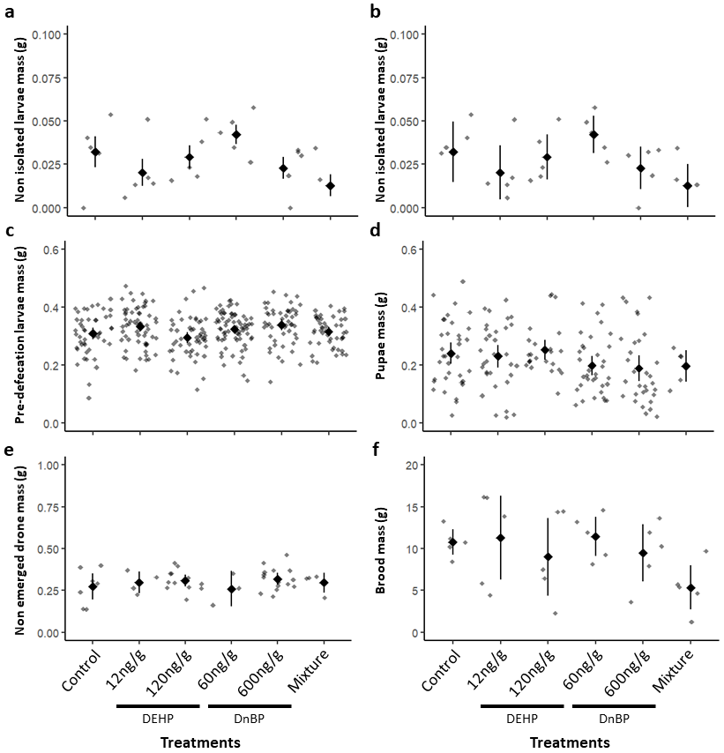
Fig. S1. Offspring mass in grams (g) in the microcolonies. a) Mass of non-isolated larvae. b) Standardised mass of non-isolated larvae (N=5 microcolonies per treatment). c) Individual mass of pre-defecation larvae. d) Individual mass of pupae. e) Individual mass of non-emerged drones. f) Total hatched offspring mass. Black points show mean values calculated per treatment with error bars indicating 95% confidence intervals. Grey dots show mean mass calculated for each microcolony (N=5 microcolonies per treatment) in graphs “a”, “b”, and “f”, and individual mass in graphs “c”, “d” and “e”.
Table S3. Summary of statistical results for the models testing effects of treatment and worker survival on offspring production. Estimates ± SE are presented on the log scale. Significant effects are indicated in bold with associated symbols: *p<0.05; **p<0.01; ***p<0.001.
Model |  | Parameters |  | Estimates ± SE | Analysis of Variance
 |  |  |  | Estimates ± SE | Chisq. | Df | p-value
Pre-  defecation | Treatment | Treatment | (intercept)  DEHP 12  DEHP 120  DnBP 60  DnBP 600  Mixture | 1.97 ± 0.35  -0.12 ± 0.49  -0.41 ± 0.50  -0.06 ± 0.49  -0.15 ± 0.49  -1.97 ± 0.64 | 11.40 | 5 | 0.0441 *
Pre-  defecation | Worker survival | (intercept)  Worker survival |  | 0.91 ± 0.47  0.11 ± 0.06 | 2.93 | 1 | 0.0871
Pre-  defecation | Both | Treatment | (intercept)  DEHP 12  DEHP 120  DnBP 60  DnBP 600  Mixture | 0.95 ± 0.62  -0.20 ± 0.41  -0.14 ± 0.45  -0.12 ± 0.39  -0.37 ± 0.44  -1.64 ± 0.62 | 7.41 | 5 | 0.1920
Pre-  defecation | Both | Worker survival |  | 0.14 ± 0.07 | 3.74 | 1 | 0.0531
Non-  emerged drones | Treatment | Treatment | (intercept)  DEHP 12  DEHP 120  DnBP 60  DnBP 600  Mixture | 0.34 ± 0.38  -0.56 ± 0.63  0.54 ± 0.48  -0.85 ± 0.69  0.76 ± 0.46  -0.56 ± 0.63 | 14.23 | 5 | 0.0142 *
Non-  emerged drones | Worker survival | (intercept)  Worker survival |  | 0.07 ± 0.45  0.05 ± 0.06 | 0.66 | 1 | 0.4170
Non-  emerged drones | Both | Treatment | (intercept)  DEHP 12  DEHP 120  DnBP 60  DnBP 600  Mixture | -0.21 ± 0.63  -0.54 ± 0.63  0.70 ± 0.50  -0.84 ± 0.69  0.75 ± 0.46  -0.49 ± 0.63 | 14.68 | 5 | 0.0118 *
Non-  emerged drones | Both | Worker survival |  | 0.07 ± 0.07 | 1.21 | 1 | 0.2713
Drones | Treatment | Treatment | (intercept)  DEHP 12  DEHP 120  DnBP 60  DnBP 600  Mixture | 2.33 ± 0.16  -0.15 ± 0.21  -0.43 ± 0.22  0.02 ± 0.20  -0.55 ± 0.23  -1.24 ± 0.29 | 26.10 | 5 | 8.521e-05 ***
Drones | Worker survival | (intercept)  Worker survival |  | 1.55 ± 0.35  0.07 ± 0.05 | 2.06 | 1 | 0.1509
Drones | Both | Treatment | (intercept)  DEHP 12  DEHP 120  DnBP 60  DnBP 600  Mixture | 1.92 ± 0.36  -0.15 ± 0.29  -0.32 ± 0.31  0.04 ± 0.28  -0.57 ± 0.31  -1.17 ± 0.36 | 15.45 | 5 | 0.0086 **
Drones | Both | Worker survival |  | 0.06 ± 0.04 | 1.98 | 1 | 0.1592

Table S4. Offspring production. Mean number of individuals ± standard error [95%CI] found in each stage from eggs to drone emergence. Significant differences from control are indicated in bold with associated symbols: *p<0.05; **p<0.01; ***p<0.001.
Treatments | Eggs | Non-isolated | Pre-defecation | Post-defecation | Pupae | Non-emerged drones | Emerged drones | Total hatched
Control | 28.8±9.2  [10.7,46.9] | 34.0±11.0  [12.4,55.6] | 7.2±1.9  [3.5,10.9] | 4.4±1.0  [2.4,6.4] | 10.0±2.0  [6.1,13.9] | 1.4±0.4  [0.6,2.2] | 10.4±1.5  [7.5,13.3] | 67.6±11.1  [45.9,89.3]
DEHP 12ng/g | 29.8±7.7  [14.7,44.9] | 46.2±11.7  [23.2,69.2] | 6.4±3.1  [0.3,12.5] | 7.0±2.6  [1.9,12.1] | 12.2±3.0  [6.4,18.0] | 0.8±0.4  [0.1, 1.5] | 9.0±2.9  [3.4,14.6] | 81.6±18.3  [45.8,117.4]
DEHP 120ng/g | 14.2±6.3  [1.9,26.5] | 34.6±14.8  [5.6,63.6] | 4.8±1.9  [1.1,8.5] | 3.6±1.8  [0.2,7.0] | 10.2±2.1  [6.1,14.3] | 2.4±0.5  [1.4,3.4] | 6.8±1.8  [3.3,10.3] | 62.4±20.9  [21.5,103.3]
DnBP 60ng/g | 18.2±7.9  [2.7,33.7] | 40.4±9.0  [22.73,58.1] | 6.8±1.7  [3.6,10.0] | 3.0±1.1  [0.9,5.2] | 14.0±2.4  [9.3,18.7] | 0.6±0.4  [-0.2,1.4] | 10.6±1.0  [8.7,12.5] | 75.4±10.3  [55.2,95.6]
DnBP 600ng/g | 21.2±9.1  [3.4,39.0] | 33.0±10.8  [11.8,54.2] | 6.2±2.2  [1.9,10.5] | 3.6±2.0  [-0.3,7.5] | 9.8±1.4  [6.9,12.7] | 3.0±0.7  [1.6,4.4] | 6.0±1.7*  [2.7,9.3] | 61.8±14.9  [32.7,90.9]
Mixture | 28.8±7.5  [14.1,43.5] | 20.0±13.0  [-5.6,45.6] | 1.0±0.6***  [-0.1,2.1] | 1.8±0.5  [0.8,2.8] | 9.6±2.5  [4.8,14.4] | 0.8±0.4  [0.1,1.5] | 3.0±1.2***  [0.6,5.4] | 36.2±13.9  [9.0,63.4]

